Using GOOGLE Docs to Gather and Analyze Data

There are currently 5 major Google Docs that you can create: Documents, Presentations,
Spreadsheets, Forms, and Drawings. I will show you how I have used Google Forms and
Spreadsheets to help students gather and analyze their data.

To create a new Google Doc, sign into your Google account, and click on the Documents link at the top of the Google.com homepage (sometimes it is hidden in the “more” option). When you see the Google Docs main page, then click on “Create” and then the document you are trying to create.
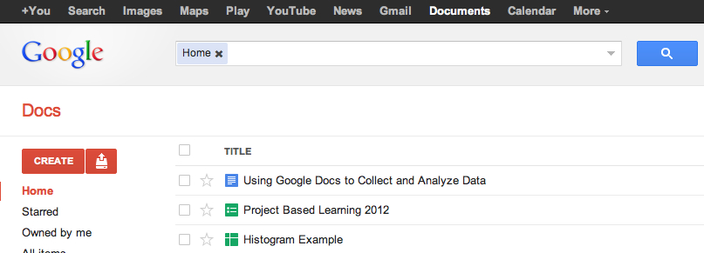

FORMS
Forms can be used to collect data from users. Forms contain questions that students can answer in a variety of ways depending on the question format (i.e. text box, paragraph text box, multiple choice, grid, etc.). In order to have students fill out the form you can do one of the following:

●Share a link with them using email addresses (you can copy and paste a class list of emails for easy sharing) that they can click on to visit the survey

●Embed the survey into an email that you send to your students

●Embed the survey into a webpage that the students can access

You can view the survey result using either a Google Spreadsheet or a Summary (Option in the “Form” menu). From the spreadsheet view, you can create graphs of the data, sort the data rows based on responses to questions, etc.

SPREADSHEETS
Google Spreadsheets are a lot like Excel Spreadsheets - and features are always being developed to increase the capabilities of Google Spreadsheets. One useful data analysis tool is a Histogram. In Excel, Histograms are in the “Data Analysis” Menu Option. But in Google Spreadsheets, you need to use a formula. The “Frequency” formula will sort data into “BINS” that you can use to graph as a histogram.

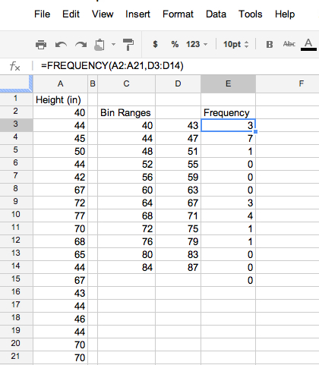

RESOURCES
32 Ways to Use Google Apps in Classrooms:
https://docs.google.com/present/view?id=0AV_Pgq_ZxwvSZGR3d3FxNnRfMjJnN3Jtc2pnaw&hl=en&authkey=COej0pME

