r

Biology Guide
2022-2023
SCI 203/204 & SCI 2030/2040

http://grading.dmschools.org
http://science.dmschools.org

Foreword
- Foreword includes purpose as well as what can be expected from the guide. (How to use this document…)
- Explains what expectations are for teacher action
How to use this document:
This curriculum guide is not…
- A lock-step instructional guide detailing exactly when and how you teach.
- Meant to restrict your creativity as a teacher.
- A ceiling of what your students can learn, nor a set of unattainable goals.
Instead, the curriculum guide is meant to be a common vision for student learning and a set of targets and success criteria directed related to grade-level standards by which to measure and report student progress and provide meaningful feedback.
The curriculum guide outlines the learning that is most essential for student success; it is our district’s guaranteed and viable curriculum. The expectation is that every student in our district, regardless of school or classroom, will have access to and learn these targets. As the classroom teacher, you should use the curriculum guide to help you to decide how to scaffold up to the learning targets and extend your students’ learning beyond them.
Within this document, you will find a foundational structure for planning sequential instruction in the classroom which can be supplemented with materials from any number of the linked resources.
Please consider this guide a living and dynamic document, subject to change and a part of a continuous feedback loop.

Biology: Year at a Glance
Semester 1 | Topic 1: Ecology 1 | Topic 2: Ecology 2 | Topic 3: Structure and Function 1 | Topic 4: Structure and Function 2
Standards Aligned | HS-LS2-1, HS-LS2-2, HS-LS2-6, HS-LS2-7 | HS-LS1-5, HS-LS2-4, HS-LS2-5 | HS-LS1-4, HS-LS1-6, HS-LS1-7 | HS-LS1-2, HS-LS1-3
iHub Resource* | Unit 3: Ecosystems

Semester 2 | Topic 5: Genetics 1 | Topic 6: Genetics 2 | Topic 7: Evolution 1 | Topic 8: Evolution 2
Standards Aligned | HS-LS1-1, HS-LS3-2 | HS-LS3-1, HS-LS3-3 | HS-LS4-1, HS-LS4-2 | HS-LS4-3, HS-LS4-5, HS-LS4-4
iHub Resource* | Unit 2: Genetics & Heredity |  | Unit 1 Evolution

*iHub is not an official adoption. This is a resource to leverage while planning. Teacher and student facing materials are free to use. iHub is guided by the NGSS standards and are phenomenon based. Three units are organized with coherent story lines, transfer tasks, and 3D assessments. To learn more about iHub go to https://www.colorado.edu/program/inquiryhub/curricula/inquiryhub-biology

Evidence shows the student ... | Topic Score
Demonstrates proficiency (AT) in all learning targets and success at Level 4 | 4.0
Demonstrates proficiency (AT) in all learning targets with partial success at Level 4 | 3.5
Demonstrates proficiency (AT) in all learning targets | 3.0
Demonstrates proficiency (AT) in at least half of the learning targets | 2.5
Demonstrates some success criteria (PT) toward all learning targets | 2.0
Demonstrates some success criteria (PT) towards some of the learning targets | 1.5
Does not yet meet minimum criteria for the targets. | 1.0
Produces no evidence appropriate to the learning targets at any level | 0
Standards-Referenced Grading Basics
Our purpose in collecting a body of evidence is to:
- Allow teachers to determine a defensible and credible topic score based on a representation of student learning over time.
Start at Level 3 when determining a topic → score.
- Clearly communicate where a student’s learning is based on a topic scale to inform instructional decisions and push student growth.
- Show student learning of targets through multiple and varying points of data
- Provide opportunities for feedback between student and teacher.

Scoring
A collaborative scoring process is encouraged to align expectations of the scale to artifacts collected. Routine use of a collaborative planning and scoring protocol results in calibration and a collective understanding of evidence of mastery. Enough evidence should be collected to accurately represent a progression of student learning as measured by the topic scale. Teachers look at all available evidence to determine a topic score. All topic scores should be defensible and credible through a body of evidence.
Guiding Practices of Standards-Referenced Grading
- A consistent 4-point grading scale will be used.
- Student achievement and behavior will be reported separately.
- Scores will be based on a body of evidence.
- Achievement will be organized by learning topic and converted to a grade at semester’s end.
- Students will have multiple opportunities to demonstrate proficiency.
- Accommodations and modifications will be provided for exceptional learners.

***Only scores of 4, 3.5, 3, 2.5, 2, 1.5, 1, and 0 can be entered as Topic Scores.

Multiple Opportunities
Philosophically, there are two forms of multiple opportunities, both of which require backwards design and intentional planning. One form is opportunities planned by the teacher throughout the unit of study and/or throughout the semester. The other form is reassessment of learning which happens after completing assessment of learning at the end of a unit or chunk of learning.
Students will be allowed multiple opportunities to demonstrate proficiency. Teachers need reliable pieces of evidence to be confident students have a good grasp of the learning topics before deciding a final topic score. To make standards-referenced grading work, the idea of “multiple opportunities” is emphasized. If after these opportunities students still have not mastered Level 3, they may then be afforded the chance to reassess.
Anatomy of a Scale
Unit Narrative:
Provide an overview and context of the unit, big understandings, and student experience—including by not limited to vocabulary, inquiry-based questions/concepts, pacing and number of lessons
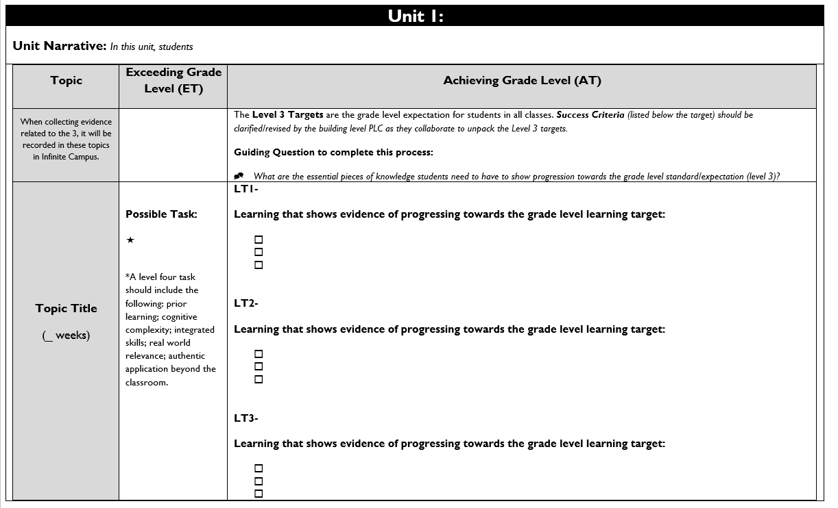

Topic Title:
Named topic in infinite campus, with approximate number of paced weeks
Exceeding Grade Level (ET):
Possible level four task listed including prior learning, cognitive complexity, integrated skills, real world relevance: authentic application beyond the classroom.

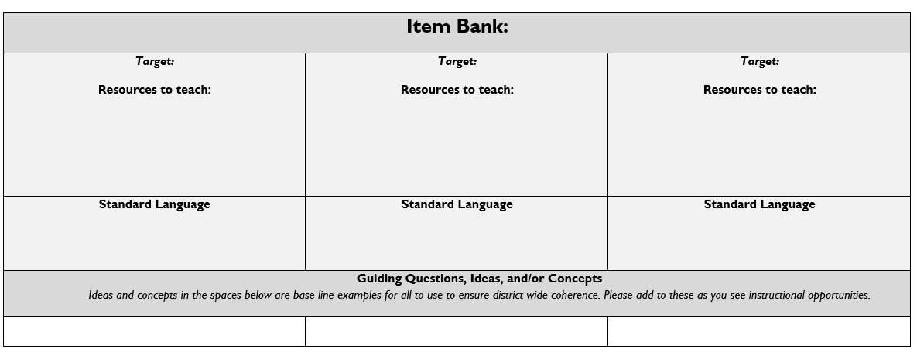
Achieving Grade Level
(AT):
Level 3 targets are listed within the topic scale and are the grade level expectation for students in all classes.
Success Criteria (listed below the target) should be clarified/revised by the building level PLC as they collaborate to unpack the Level 3 targets.

Item Bank:
Linked resources for each learning target. Guiding/Inquiry questions, ideas, and/or concepts are below the base line examples to ensure district wide coherence.

Topic 1: Ecology 1

Science and Engineering Practices (SEP)
Disciplinary Core Ideas (DCI)
Cross Cutting Concepts (CCC)

Using Mathematics and Computational Thinking

Constructing Explanations and Designing Solutions

Engaging in Argument from Evidence

LS2.A: Interdependent Relationships in Ecosystems

LS2.C: Ecosystem Dynamics, Functioning, and Resilience

LS4.D: Biodiversity and Humans

ETS1.B: Developing Possible Solutions

Scale, Proportion, and Quantity

Stability and Change

Ecology 1 | Achieving Grade Level (AT)
LT1A- Use mathematical representations to support explanations that affect carrying capacity of ecosystems at different scales. (HS-LS2-1)
LT1B- Use mathematical representations to support and revise explanations based on evidence about factors affecting biodiversity and populations. (HS-LS2-2)

LT1C- Design, evaluate, and refine a solution for reducing the impacts of human activities on the environment and biodiversity. (HS-LS2-7)

LT1D - Evaluate the claims, evidence, and reasoning that complex interactions in ecosystems maintain relatively stable conditions but changing conditions may result in a new ecosystem. (HS-LS2-6)

Topic 2: Ecology 2

Science and Engineering Practices (SEP)
Disciplinary Core Ideas (DCI)
Cross Cutting Concepts (CCC)

Developing and Using Models

Using Mathematics and Computational Thinking
LS1.C: Organization for Matter and Energy Flow in Organisms

LS2.B: Cycles of Matter and Energy Transfer in Ecosystems
PS3.D: Energy in Chemical Processes

Energy and Matter

Systems and System Models

Ecology 2 | Achieving Grade Level (AT)
LT2A- Use a model to illustrate how photosynthesis transforms light into stored chemical energy. (HS-LS1-5)

LT2B- Use mathematical representations to support claims for the cycling of matter and flow of energy among organisms in an ecosystem. (HS- LS2-4)

LT2C- Develop a model to illustrate the role of photosynthesis and cellular respiration in the cycling of carbon among biosphere, atmosphere, hydrosphere, and geosphere (HS-LS2-5)

Topic 3: Structure and Function 1

Science and Engineering Practices (SEP)
Disciplinary Core Ideas (DCI)
Cross Cutting Concepts (CCC)

Developing and Using Models

Constructing Explanations and Designing Solutions

LS1.B: Growth and Development of Organisms

LS1.C: Organization for Matter and Energy Flow in Organisms

Energy and Matter

Systems and System Models

Structure and Function 1 | Achieving Grade Level (AT)
LT3A- Use a model to illustrate the role of cellular division (mitosis) and differentiation in producing and maintaining complex organisms. (HS-LS1-4)

LT3B- Construct and revise an explanation based on evidence for how carbon, hydrogen, and oxygen from sugar molecules may combine with other elements to form amino acids and/or other large carbon-based molecules. (HS-LS1-6)

LT3C- Use a model to illustrate the release of energy in bonds, including the inputs and outputs of cellular respiration. HS-LS1-7
- Identify the inputs and outputs of cellular respiration.
- Trace the flow of energy and matter through the model of cellular respiration.
- Describe the relationship between the Law of conservation of matter and energy to cellular respiration.

Topic 4: Structure and Function 2

Science and Engineering Practices (SEP)
Disciplinary Core Ideas (DCI)
Cross Cutting Concepts (CCC)

Developing and Using Models

Planning and Carrying Out Investigations

LS1.A: Structure and Function

Systems and System Models

Stability and Change

Structure and Function 2 | Achieving Grade Level (AT)
LT4A- Develop and use a model to illustrate how the interactions between systems provides specific functions in multicellular organisms. (HS-LS1-2)
- Creates a model identify and describe the major components within at least two major organ systems.
- Revise model using evidence from an investigation to explain component interactions/functions within at least two major organ systems.
- Compare and contrast ways the functions of two different systems affect one another.

LT4B- Plan and conduct an investigation to provide evidence that feedback mechanisms maintain homeostasis. (HS-LS1-3)
- Describe a homeostasis related phenomenon and compose a testable question related to maintaining homeostasis.
- Identify evidence needed to answer the testable question including external environmental factor(s) and how it will be measured.
- Identify evidence needed to answer the testable question including living system response(s) to stabilize and maintain the system’s internal conditions and how response(s) will be measured.
- Collect data (actual or simulation generated) for changed in environmental factor(s) and living system response(s) to the factor change.

Topic 5: Genetics 1

Science and Engineering Practices (SEP)
Disciplinary Core Ideas (DCI)
Cross Cutting Concepts (CCC)

Developing and Using Models

Constructing Explanations and Designing Solutions

Engaging in Argument from Evidence

LS1.B: Growth and Development of Organisms

LS1.A: Structure and Function

LS3.B: Variation of Traits

Systems and System Models

Structure and Function

Cause and Effect

Genetics 1 | Achieving Grade Level (AT)
LT5A- Construct an explanation based on evidence for how the structure of DNA determines the structure of proteins which carry out the essential functions of life through systems of specialized cells. (HS-LS1-1)

LT5B- Make and defend a claim based on evidence suggesting the sources of genetic variation through mutations. (HS-LS3-2)
- Explain how mutations result from errors during replication.
- Explain how mutations result from environmental factors.
- Describe how variations produced by mutation and meiosis can be inherited.
- Connect mutations to changes in DNA and the resultant changes in protein synthesis.

Topic 6: Genetics 2

Science and Engineering Practices (SEP)
Disciplinary Core Ideas (DCI)
Cross Cutting Concepts (CCC)

Asking Questions and Defining Problems

Analyzing and Interpreting Data

LS1.A: Structure and Function

LS3.A: Inheritance of Traits

LS3.B: Variation of Traits

Cause and Effect

Scale, Proportion, and Quantity

Genetics 2 | Achieving Grade Level (AT)
LT6A- Ask questions to clarify relationships about the role of DNA and chromosomes in coding the instructions for traits passed from parents to offspring. (HS-LS3-1)

LT6B- Apply concepts of statistics and probability to explain the variation and distribution of expressed traits in a population. (HS-LS3-3)

Topic 7: Evolution 1

Science and Engineering Practices (SEP)
Disciplinary Core Ideas (DCI)
Cross Cutting Concepts (CCC)

Obtaining, Evaluating, and Communicating Information

Constructing Explanations and Designing Solutions

LS4.A: Evidence of Common Ancestry and Diversity

LS4.B: Natural Selection

LS4.C: Adaptation

Patterns

Cause and Effect

Evolution 1 | Achieving Grade Level (AT)
LT7A- Construct an argument for evolution based on common ancestry and communicate how multiple lines of evidence support these explanations. (HS-LS4-1)
- Describe how commonalities between DNA sequences or amino acid sequences support the idea of a common ancestry.
- Create inferences of possible lines of evolutionary descent based on the fossil record.
- Compare and contrast anatomical (homologous and vestigial) and embryological structures to suggest evolutionary relationships.

LT7B- Construct an explanation based on evidence that evolution through the process of natural selection primarily results from a combination of four factors. (HS-LS4-2)
- Describe why variation is necessary for the process of evolution to occur.
- Describe why reproduction is necessary for the process of evolution to occur.
- Describe how competition drives the process of evolution to occur.
- Provide reasons for the trend of an advantageous trait in a population over time.

Topic 8: Evolution 2

Science and Engineering Practices (SEP)
Disciplinary Core Ideas (DCI)
Cross Cutting Concepts (CCC)

Analyzing and Interpreting Data

Constructing Explanations and Designing Solutions

Engaging in Argument from Evidence

LS4.B: Natural Selection

LS4.C: Adaptation

Cause and Effect

Patterns

Evolution 2 | Achieving Grade Level (AT)
LT8A- Apply concepts of statistics and probability to support explanations that organisms with an advantageous heritable trait tend to increase in proportion to organisms lacking this trait. (HS-LS4-3)

LT8B- Construct an explanation based on evidence for how natural selection leads to adaptation of populations. (HS-LS4-4)

LT8C- Evaluate evidence to create a logical argument that changes in environmental conditions may result in the change, development, or extinction of species over time. (HS-LS4-5)
- Identify and describe specific situations where a change in the environment causes the number of individuals in a species to change (increases vs extinction).
- Identify and describe specific situations where a change in the environment may cause specification.

