AP Physics C: Des Moines Public Schools
2017-18 CURRICULUM GUIDE SCI529/530

AP Physics C
AP Physics C: Mechanics is equivalent to a one-semester, calculus-based, college-level physics course, especially appropriate for students planning to specialize or major in physical science or engineering. The course explores topics such as kinematics; Newton’s laws of motion; work, energy and power; systems of particles and linear momentum; circular motion and rotation; and oscillations and gravitation. Introductory differential and integral calculus is used throughout the course.

AP Physics C – Course Content
The AP Physics C Mechanics:
• Mechanics course applies both differential and integral calculus and provides instruction in each of the following six content areas:
• Kinematics
• Newton’s laws of motion
• Work, energy and power
• Systems of particles and linear momentum
• Circular motion and rotation
• Oscillations and gravitation

The AP Physics C: Electricity and Magnetism course applies both differential and integral calculus, and builds upon the AP Physics C: Mechanics course by providing instruction in each of the following five content areas:
• Electrostatics
• Conductors, capacitors, and dielectrics
• Electric circuits
• Magnetic fields
• Electromagnetism

AP Physics C Exam: Format of Assessments – Mechanics
Section I: Multiple Choice | 35 Questions | 45 Minutes | 50% of Exam Score
Section II: Free Response | 3 Questions | 45 Minutes | 50% of Exam Score

AP Physics C Exam: Format of Assessments – E&M
Section I: Multiple Choice | 35 Questions | 45 Minutes | 50% of Exam Score
Section II: Free Response | 3 Questions | 45 Minutes | 50% of Exam Score

Link to DMPS Grading Resources: http://grading.dmschools.org
Link to Course Information @ AP Central: http://apcentral.collegeboard.com/apc/public/courses/teachers_corner/2264.html
Semester 1 Topics | College Board Curriculum Framework Alignment  AP Physics C Mechanics
Motion
Forces
Energy
Momentum
Rotational
Science Practices

Semester 2 Topics | College Board Curriculum Framework Alignment  AP Physics C E&M
Rotation
SHM & Waves
Electrostatics: Forces & Fields
Electrostatics: Potential & Energy
Circuits
Magnetism
Applying Scientific Knowledge
Science Practices

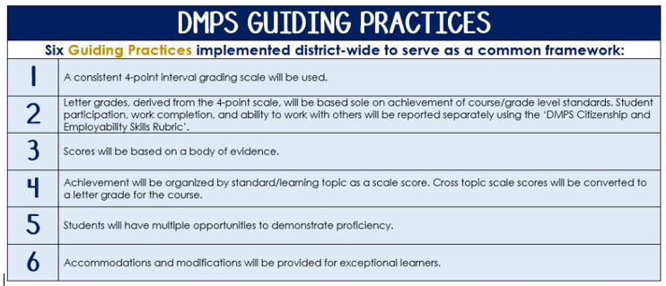
Standards-Referenced Grading Basics
The teacher designs instructional activities and assessments that grow and measure a student’s skills in the elements identified on our topic scales. Each scale features many such skills and knowledges, also called learning targets. These are noted on the scale below with letters (A, B, C) and occur at Levels 2 and 3 of the scale. In the grade book, a specific learning activity could be marked as being 3A, meaning that the task measured the A item at Level 3.

The Body of Evidence in a Process-Based Course
Process-Based SRG is defined as an SRG course design where the same scale recurs throughout the course, but the level of complexity of text and intricacy of task increase over time.

AP Physics C cycles students through some topics repeatedly as they progress through the course, with changing content and an increasing complexity of the scientific problem solving, analysis, and expectations throughout.

To account for this, process-based courses like this have their evidence considered in a “Sliding Window” approach. When determining the topic score for any given grading topic, the most recent evidence determines the topic score. Teacher discretion remains a vital part of this determination, but it is hard to overlook evidence from the most recent (and therefore rigorous) assessments.

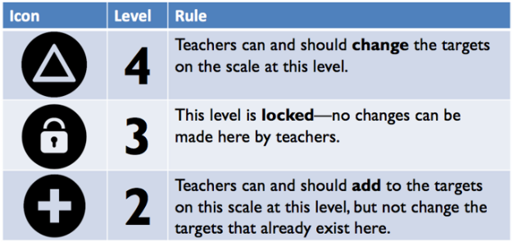
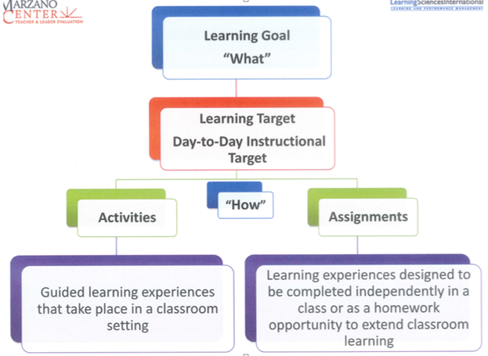

Motion
Text and Resources

Topic | 4 | 3 | 2
 | In addition to meeting the learning goal, the student demonstrates in-depth inferences and applications that go beyond the goal.

Forces
Text and Resources

Topic | 4 | 3 | 2
 | In addition to meeting the learning goal, the student demonstrates in-depth inferences and applications that go beyond the goal.

Energy
Text and Resources

Topic | 4 | 3 | 2
 | In addition to meeting the learning goal, the student demonstrates in-depth inferences and applications that go beyond the goal.

Momentum
Text and Resources

Topic | 4 | 3 | 2
 | In addition to meeting the learning goal, the student demonstrates in-depth inferences and applications that go beyond the goal.

Rotational
Text and Resources

Topic | 4 | 3 | 2
 | In addition to meeting the learning goal, the student demonstrates in-depth inferences and applications that go beyond the goal.

Science Practices
Text and Resources

Topic | 4 | 3 | 2
 | In addition to meeting the learning goal, the student demonstrates in-depth inferences and applications that go beyond the goal.

SHM & Waves
Text and Resources

Topic | 4 | 3 | 2
 | In addition to meeting the learning goal, the student demonstrates in-depth inferences and applications that go beyond the goal.

Electrostatics: Forces & Fields
Text and Resources

Topic | 4 | 3 | 2
 | In addition to meeting the learning goal, the student demonstrates in-depth inferences and applications that go beyond the goal.

Electrostatics: Potential & Energy
Text and Resources

Topic | 4 | 3 | 2
 | In addition to meeting the learning goal, the student demonstrates in-depth inferences and applications that go beyond the goal.

Circuits
Text and Resources

Topic | 4 | 3 | 2
 | In addition to meeting the learning goal, the student demonstrates in-depth inferences and applications that go beyond the goal.

Magnetism
Text and Resources

Topic | 4 | 3 | 2
 | In addition to meeting the learning goal, the student demonstrates in-depth inferences and applications that go beyond the goal.

Applying Scientific Knowledge
Text and Resources

Topic | 4 | 3 | 2
 | In addition to meeting the learning goal, the student demonstrates in-depth inferences and applications that go beyond the goal.

SRG Scale Score | Topic:  AP-Style Assessments | AP Exam  Score Conversion
4 | In addition to meeting the learning goal, the student demonstrates in-depth inferences and applications that go beyond the goal. | 90-100%
3.5 | Student’s performance reflects exceptional facility with some, but not all Level 4 learning targets. | 80-89%
3  Learning Goal | Student’s performance reflects success on all Level 3 learning targets. | 70-79%
2.5 | Student’s performance reflects success on some, but not all, Level 3 learning targets | 60-69%
2 | Student’s performance reflects success on all Level 2 learning targets. | 50-59%
1.5 | Student’s performance reflects success on some but not all Level 2 learning targets | 40-49%
1 | Student’s performance reflects insufficient progress towards foundational skills and knowledge. | 20-39%

