AP Physics 2: Des Moines Public Schools
2017-18 CURRICULUM GUIDE SCI527A/528A

AP Physics 2
AP Physics 2 is an algebra-based, introductory college-level physics course. Students cultivate their understanding of physics through inquiry-based investigations as they explore these topics: fluids; thermodynamics; electrical force, field, and potential; electric circuits; magnetism and electromagnetic induction; geometric and physical optics; and quantum, atomic, and nuclear physics.

AP Physics 2 – Course Content:
Students explore principles of fluids, thermodynamics, electricity, magnetism, optics, and topics in modern physics. The course is based on seven big ideas, which encompass core scientific principles, theories, and processes that cut across traditional boundaries and provide a broad way of thinking about the physical world. The following are the big ideas:
• Objects and systems have properties such as mass and charge. Systems may have internal structure.
• Fields existing in space can be used to explain interactions.
• The interactions of an object with other objects can be described by forces.
• Interactions between systems can result in changes in those systems.
• Changes that occur as a result of interactions are constrained by conservation laws.
• Waves can transfer energy and momentum from one location to another without the permanent transfer of mass and serve as a mathematical model for the description of other phenomena.
• The mathematics of probability can be used to describe the behavior of complex systems and to interpret the behavior of quantum mechanical systems.

AP Physics 2 – Scientific Practices:
• Use representations and models to communicate scientific phenomena and solve scientific problems • Use mathematics appropriately
• Engage in scientific questioning to extend thinking or to guide investigations • Work with scientific explanations and theories
• Plan and implement data collection strategies in relation to a particular scientific question • Perform data analysis and evaluation of evidence
• Connect and relate knowledge across various scales, concepts, and representations in and across domains.

AP Physics 2 Exam: Format of Assessment – 3 Hours
Section I: Multiple Choice | 50 Questions | 90 Minutes | 50% of Exam Score
• Discrete Items, Items in Sets, and Multi-Select Items (two options are correct)

Section II: Free Response | 4 Questions | 90 Minutes | 50% of Exam Score
• Experimental Design (1 question)
• Quantitative/Qualitative Translation (1 question)
• Short Answer (2 questions)

Link to DMPS Grading Resources: http://grading.dmschools.org
Link to Course Resources: http://science.dmschools.org
Link to Course Information @ AP Central: http://apcentral.collegeboard.com/apc/public/courses/teachers_corner/225113.html
Semester 1 Topics | College Board Curriculum Framework Alignment
Thermal Physics | Big Idea 1: Objects and systems have properties such as mass and charge. Systems may have internal structure.  Big Idea 3: The interactions of an object with other objects can be described by forces.  Big Idea 4: Interactions between systems can result in changes in those systems.  Big Idea 5: Changes that occur as a result of interactions are constrained by conservation laws.  Big Idea 7: The mathematics of probability can be used to describe the behavior of complex systems and to interpret the behavior of quantum mechanical systems.
Fluids | Big Idea 1: Objects and systems have properties such as mass and charge. Systems may have internal structure.  Big Idea 3: The interactions of an object with other objects can be described by forces.  Big Idea 5: Changes that occur as a result of interactions are constrained by conservation laws.
Electrostatics – Forces & Fields | Big Idea 1: Objects and systems have properties such as mass and charge. Systems may have internal structure.  Big Idea 2: Fields existing in space can be used to explain interactions.  Big Idea 3: The interactions of an object with other objects can be described by forces.  Big Idea 4: Interactions between systems can result in changes in those systems.  Big Idea 5: Changes that occur as a result of interactions are constrained by conservation laws.
Electrostatics – Potential & Energy | Big Idea 1: Objects and systems have properties such as mass and charge. Systems may have internal structure.  Big Idea 2: Fields existing in space can be used to explain interactions.  Big Idea 3: The interactions of an object with other objects can be described by forces.  Big Idea 4: Interactions between systems can result in changes in those systems.  Big Idea 5: Changes that occur as a result of interactions are constrained by conservation laws.
Circuits | Big Idea 1: Objects and systems have properties such as mass and charge. Systems may have internal structure.  Big Idea 4: Interactions between systems can result in changes in those systems.  Big Idea 5: Changes that occur as a result of interactions are constrained by conservation laws.
Science Practices | Science Practices 1: Use representations and models to communicate scientific phenomena and solve scientific problems  Science Practices 2: Use mathematics appropriately;  Science Practices 3: Engage in scientific questioning to extend thinking or to guide investigations within the context of the AP course;  Science Practices 4: Plan and implement data collection strategies in relation to a particular scientific question;  Science Practices 5: Perform data analysis and evaluation of evidence;  Science Practices 7: Connect and relate knowledge across various scales, concepts, and representations in and across domains

Semester 2 Topics | College Board Curriculum Framework Alignment
Circuits | Big Idea 1: Objects and systems have properties such as mass and charge. Systems may have internal structure.  Big Idea 4: Interactions between systems can result in changes in those systems.  Big Idea 5: Changes that occur as a result of interactions are constrained by conservation laws.
Magnetism | Big Idea 1: Objects and systems have properties such as mass and charge. Systems may have internal structure.  Big Idea 2: Fields existing in space can be used to explain interactions.  Big Idea 3: The interactions of an object with other objects can be described by forces.  Big Idea 4: Interactions between systems can result in changes in those systems.
Optics | Big Idea 6: Waves can transfer energy and momentum from one location to another without the permanent transfer of mass and serve as a mathematical model for the description of other phenomena.
Modern | Big Idea 1: Objects and systems have properties such as mass and charge. Systems may have internal structure.  Big Idea 3: The interactions of an object with other objects can be described by forces.  Big Idea 4: Interactions between systems can result in changes in those systems.  Big Idea 5: Changes that occur as a result of interactions are constrained by conservation laws.  Big Idea 6: Waves can transfer energy and momentum from one location to another without the permanent transfer of mass and serve as a mathematical model for the description of other phenomena.  Big Idea 7: The mathematics of probability can be used to describe the behavior of complex systems and to interpret the behavior of quantum mechanical systems.
Applying Scientific Knowledge | Science Practices 1: Use representations and models to communicate scientific phenomena and solve scientific problems  Science Practices 2: Use mathematics appropriately;  Science Practices 3: Engage in scientific questioning to extend thinking or to guide investigations within the context of the AP course;  Science Practices 4: Plan and implement data collection strategies in relation to a particular scientific question;  Science Practices 5: Perform data analysis and evaluation of evidence;  Science Practices 7: Connect and relate knowledge across various scales, concepts, and representations in and across domains
Science Practices | Science Practices 1: Use representations and models to communicate scientific phenomena and solve scientific problems  Science Practices 2: Use mathematics appropriately;  Science Practices 3: Engage in scientific questioning to extend thinking or to guide investigations within the context of the AP course;  Science Practices 4: Plan and implement data collection strategies in relation to a particular scientific question;  Science Practices 5: Perform data analysis and evaluation of evidence;  Science Practices 7: Connect and relate knowledge across various scales, concepts, and representations in and across domains

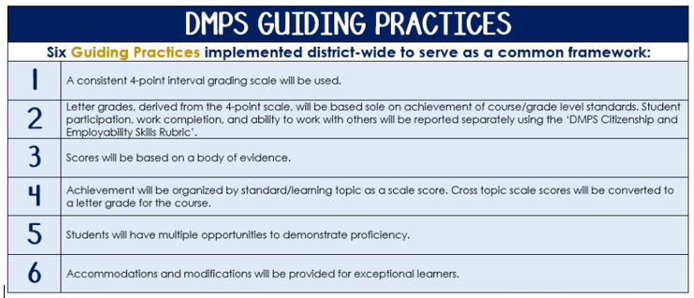
Standards-Referenced Grading Basics
The teacher designs instructional activities and assessments that grow and measure a student’s skills in the elements identified on our topic scales. Each scale features many such skills and knowledges, also called learning targets. These are noted on the scale below with letters (A, B, C) and occur at Levels 2 and 3 of the scale. In the grade book, a specific learning activity could be marked as being 3A, meaning that the task measured the A item at Level 3.

The Body of Evidence in a Process-Based Course
Process-Based SRG is defined as an SRG course design where the same scale recurs throughout the course, but the level of complexity of text and intricacy of task increase over time.

AP Physics 2 cycles students through some topics repeatedly as they progress through the course, with changing content and an increasing complexity of the scientific problem solving, analysis, and expectations throughout.

To account for this, process-based courses like this have their evidence considered in a “Sliding Window” approach. When determining the topic score for any given grading topic, the most recent evidence determines the topic score. Teacher discretion remains a vital part of this determination, but it is hard to overlook evidence from the most recent (and therefore rigorous) assessments.

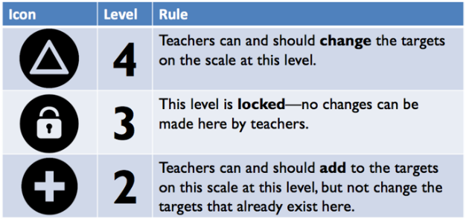
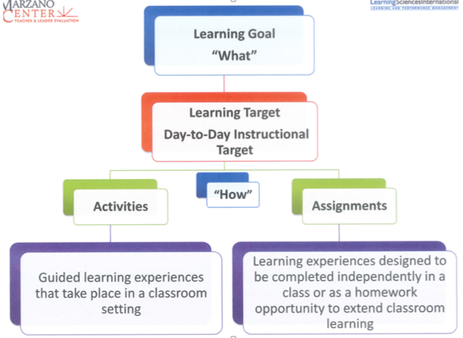

Thermal Physics
Text and Resources
Identify and define: Thermal Conductivity, conduction, convection, radiation, energy (kinetic energy, potential energy, internal energy), transfer energy (heat and work), thermodynamic processes (isobaric, isothermal, isochoric, and adiabatic),
College Physics Text: 11.3 – 11.8, 12.1 – 12.8,

Topic | 4 | 3 | 2
 | 4A Students can use the model to make predictions and describe observations made in the real world. (Examples: airplanes, temperature differences, etc.)  4A Students can interpret data to identify possible errors in an experimental setup based upon the model for pressure, volume, number of particles, and temperature. | 3A. Develop a model to make predictions about how pressure, volume, number of particles, and temperature change in a closed system. Explain how changes in one variable affect the other variables.  3B Student is able to predict qualitative and quantitative changes in a thermodynamic system involving transfer of energy due to heat or work done and justify those predictions.  3C Students will utilize an entropy model to describe the second law of thermodynamics and reversible and irreversible processes.  3D Student will develop and utilize a model to qualitatively and quantitatively predict changes in an object as the object is heated. | 2A. Describe the relationship between pressure, volume, number of particles, and temperature in a closed system and describe the interaction of the individual particles in the system.  2B Student is able to interpret a pressure-volume curve to determine the work done on or by the object or system.  2B Student is able to identify thermodynamic processes from given data and graphs.  2C Student is able to identify the relationship between temperature and average kinetic energy.  2C Student is able to identify where energy is “lost” in a process.  2D Student is able to identify changes in internal structure based on changes in temperature and heat transferred.

Fluids
Text and Resources
Identify and define: pressure, volume, density, Bernoulli’s equation, continuity equation, hydrostatic pressure, atmospheric pressure, gauge pressure, absolute pressure
College Physics Text: 13.1 – 13.8

Topic | 4 | 3 | 2
 | In addition to meeting the learning goal, the student demonstrates in-depth inferences and applications that go beyond the goal. | 3A The student is able to determine the density of an object and/or compare densities of several objects.  3B The student is able to make qualitative and quantitative predictions for moving fluids using Bernoulli’s equation and the continuity equation when other variables are changed.  3C The student is able to create and use a model to describe how energy is stored and transferred in fluid systems.  3D The student is able to develop and utilize a model to analyze floating, sinking, and neutral buoyant objects. | 2A The student is able to select from experimental data the information necessary to determine the density of an object.  2B The student is able to determine the relationship between force and pressure for moving fluids.  2B The student is able to determine the relationship between speed and cross-sectional area for moving fluids.  2C The student is able to identify where energy is stored in fluid systems.  2D The student is able to identify the variables that affect the buoyancy of an object and qualitatively explain how they change in relation to each other.

Electrostatics: Forces & Fields
Text and Resources
Identify and define: charge, electric field, electric force, Coulomb’s law, charge by: friction, induction, polarization,
College Physics Text: 20.1-20.20.7

Topic | 4 | 3 | 2
 | 4A Students are able to challenge claims that polarization of electric charge or separation of charge must result in a net charge on the object, students must use evidence.  4A The student is able to explain and/or analyze the results of experiments in which electric charge rearrangement occurs by electrostatic induction, or is able to refine a scientific question relating to such an experiment by identifying anomalies in a data set or procedure. | 3A The student is able to develop and utilize a model of charge conservation in order to explain how objects are charged to create a net charge.  3B. The student is able to predict the direction and the magnitude of the force exerted on an object from multiple point charges or multiple electric fields.  3C The student is able to predict properties of an electric field from multiple charges, including, the direction, the magnitude, and the vector field. | 2A The student is able to make claims about conservation of charge, positive, and negative charge.  2A The student is able to identify conductors and insulators and describe their properties.  2B. The student is able to predict the direction and the magnitude of the force exerted on an object from a point charge or an electric field.  2C. The student is able to predict properties of an electric field from a point charge, including, the direction, the magnitude, and the vector field.

Electrostatics: Potential & Energy
Text and Resources
Identify and define: potential, equipotential lines, electric potential energy
College Physics Text: 21.1 – 21.8

Topic | 4 | 3 | 2
 | In addition to meeting the learning goal, the student demonstrates in-depth inferences and applications that go beyond the goal. | 3A – Develop a model to analyze equipotential lines to determine the effect of that field on an electrically charged objects.  3B. Develop a model to analyze the relationship between electric field and electric potential assuming a constant electric field.  3C Develop a model to analyze the conservation of energy of a charged particle moving through a potential difference. | 2A – Analyze electric potential lines to qualitatively describe the motion of the charged particle.  2A – Identify areas of high potential and low potential using equipotential lines.  2B - Calculate the average value of the magnitude of the electric field in a region from a description of the electric potential in that region using the displacement along the line on which the difference in potential is evaluated.  2B – Calculate the electric potential energy or electric potential due to the arrangement of multiple point charges.  2C Qualitatively predict changes in motion of a charged particle moving through a potential difference.

Circuits
Text and Resources
Identify and define: resistors, capacitors, voltmeter, ammeter, Kirchoff’s Laws, loop rule, junction rule, parallel, series, complex, power
College Physics Text: 22.1 – 22.6, 23.1 – 23.7

Topic | 4 | 3 | 2
 | In addition to meeting the learning goal, the student demonstrates in-depth inferences and applications that go beyond the goal. | 3A Develop a model, using Kirchoff’s Laws, to analyze a complex circuit containing multiple power sources and resistors.  3B Develop a model to analyze a complex circuit containing a single power source, resistors, and capacitors.  3C Develop a model to track energy and power consumption in a circuit. Predict changes when elements of the circuit are change based on conservation of energy and changes of power consumption. | 2A Choose and justify the selection of data needed to determine the resistivity for a given material.  2A Identify simple parallel and series circuits with resistors.  2A Analyze simple parallel and series circuits with resistors.  2B Choose and justify the selection of data needed to determine the capacitance of a capacitor.  2B Identify simple parallel and series circuits with capacitors.  2B Analyze simple parallel and series circuits with capacitors.  2C Calculate power dissipated throughout a circuit.  2C Calculate energy stored in a capacitor.

Science Practices
Text and Resources

Topic | 4 | 3 | 2
 | In addition to score 3.0 performance, the student demonstrates in-depth inferences and applications that go beyond the learning goal.  - Engage in scientific questioning to extend thinking or guide investigations within the context of an AP course (SP.3)  OR  - Connect and relate knowledge across various scales, concepts, and representations in and across domains (SP.7) | Apply scientific practices to physics.  - Use representations and models (graphs, diagrams, tables, charts) to communicate scientific phenomena and solve scientific problems (SP.1)  - Use mathematics appropriately (SP.2)  - Implement data collection strategies (SP.4) and perform data analysis and evaluate evidence (SP.5)  - Support conclusions using experimental evidence and scientific reasoning | A level 2 in scientific practices fails to meet the learning goal in two areas.  - Use representations and models to communicate scientific phenomena and solve scientific problems (SP.1)  - Use mathematics appropriately (SP.2)  - Implement data collection strategies (SP.4) and perform data analysis and evaluate evidence (SP.5)  - Support conclusions using experimental evidence and scientific reasoning

Magnetism
Text and Resources
Identify and define: magnetic field, magnetic flux, north pole, south pole, magnetic induction, right hand rules
College Physics Text: Chapters 24 and 25

Topic | 4 | 3 | 2
 | In addition to meeting the learning goal, the student demonstrates in-depth inferences and applications that go beyond the goal.  4 C. Construct a model to explain the function of an electromagnetic device in which an induced emf is produced by a changing magnetic flux through an area defined by a current loop or of the effect on behavior of a device in which an induced emf is produced by a constant magnetic field through a changing area. | 3 A. Develop a model to analyze a magnetic field and its effect on its surroundings.  3 B. Develop a quantitative model to analyze the forces between a magnetic field and a magnetic dipole, or moving electric charge.  3 C. Develop a model to analyze the magnetic field and forces created by moving charges. | 2 A. Compare and contrast monopoles (gravitational fields) and dipoles (magnetic field and electric dipole field.)  2 A. Describe the effect of placing a magnetic dipole placed in a magnetic field.  2 A. Describe the effect of placing a moving charge in a magnetic field.  2 B. Calculate the force exerted on an object moving perpendicular to the magnetic field.  2 B. Write a net force equation for the forces acting on a moving object in a magnetic field.  2 B. Correctly use the right hand rule to describe the direction of magnetic force acting on a moving charge.  2 C. Diagram the magnetic field around a long straight wire or a pair of parallel wires.  2 C. Correctly use the right hand rule to describe the direction of a magnetic field due to moving charges.

Optics
Text and Resources
Identify and define: wave particle duality of light, normal, angle of incidence, angle of reflection, angle of refraction, interference, superposition, spherical mirrors, thin lenses, refraction, diffraction, thin film interference
College Physics Text: Chapter 17 and 18

Topic | 4 | 3 | 2
 | In addition to meeting the learning goal, the student demonstrates in-depth inferences and applications that go beyond the goal. | 3A. Develop a model for reflection of light. Utilize the model to make predictions about the location, magnification, and orientation of images created through reflection.  3B. Develop a model for refraction of light. Utilize the model to make predictions about the location, magnification, and orientation of images created through refraction.  3C. Develop a model for analyzing the wavelike properties of light. Utilize the model to predict areas of constructive and destructive interference in Young’s Double Slit, diffraction, and thin film interference. | 2 A. Student develop and utilize angle of incidence and angle of reflection.  2A. Students can trace light rays and virtual light rays to approximate an image.  2B. Develop the concept of refraction and explain why light bends at a boundary.  2B. Students can trace light rays and virtual light rays to approximate an image.  3C. Identify the properties of light that create interference.  3C. Utilizing interference predict areas of constructive and destructive interference.

Modern
Text and Resources
Identify and define: photo-electric effect, work function, electron energy levels, absorption spectra, emission spectra, uncertainty principle, Bohr’s model of the atom, alpha decay, beta decay, gamma decay
College Physics Text: Chapters 28, 29, 30

Topic | 4 | 3 | 2
 | In addition to meeting the learning goal, the student demonstrates in-depth inferences and applications that go beyond the goal. | 3A. Develop a model to analyze the energy associated with particles in the photo-electric effect.  3B. Develop a model to analyze the energy levels within an atom. Utilize Bohr’s model to predict absorption and emission spectra.  3C Develop a model to analyze nuclear decays. Utilize conservation of mass and mass deficit to determine the energy in a nuclear decay or fission. | 2A. Identify the factors that affect the energy of an ejected electron.  2A. Identify the work function of a material and describe how it affects the energy of an ejected electron.  2B. Identify parts of the atom and Bohr’s model of the atom.  2B. Identify the factors that affect absorption and emission spectra.  2C. Identify alpha, beta, and gamma decay.  2C. Identify the factors that affect nuclear decay rate.  2C. Describe the purpose of the strong and weak forces in an atom.

Applying Scientific Knowledge
Text and Resources

Topic | 4 | 3 | 2
 | In addition to meeting the learning goal, the student demonstrates in-depth inferences and applications that go beyond the goal.

SRG Scale Score | Topic:  AP-Style Assessments | AP Exam  Score Conversion
4 | In addition to meeting the learning goal, the student demonstrates in-depth inferences and applications that go beyond the goal. | 90-100%
3.5 | Student’s performance reflects exceptional facility with some, but not all Level 4 learning targets. | 80-89%
3  Learning Goal | Student’s performance reflects success on all Level 3 learning targets. | 70-79%
2.5 | Student’s performance reflects success on some, but not all, Level 3 learning targets | 60-69%
2 | Student’s performance reflects success on all Level 2 learning targets. | 50-59%
1.5 | Student’s performance reflects success on some but not all Level 2 learning targets | 40-49%
1 | Student’s performance reflects insufficient progress towards foundational skills and knowledge. | 20-39%

