AP Physics 2: Des Moines Public Schools
2017-18 CURRICULUM GUIDE SCI527A/528A

AP Physics 2
AP Physics 2 is an algebra-based, introductory college-level physics course. Students cultivate their understanding of physics through inquiry-based investigations as they explore these topics: fluids; thermodynamics; electrical force, field, and potential; electric circuits; magnetism and electromagnetic induction; geometric and physical optics; and quantum, atomic, and nuclear physics.

AP Physics 2 – Course Content:
Students explore principles of fluids, thermodynamics, electricity, magnetism, optics, and topics in modern physics. The course is based on seven big ideas, which encompass core scientific principles, theories, and processes that cut across traditional boundaries and provide a broad way of thinking about the physical world. The following are the big ideas:
• Objects and systems have properties such as mass and charge. Systems may have internal structure.
• Fields existing in space can be used to explain interactions.
• The interactions of an object with other objects can be described by forces.
• Interactions between systems can result in changes in those systems.
• Changes that occur as a result of interactions are constrained by conservation laws.
• Waves can transfer energy and momentum from one location to another without the permanent transfer of mass and serve as a mathematical model for the description of other phenomena.
• The mathematics of probability can be used to describe the behavior of complex systems and to interpret the behavior of quantum mechanical systems.

AP Physics 2 – Scientific Practices:
• Use representations and models to communicate scientific phenomena and solve scientific problems • Use mathematics appropriately
• Engage in scientific questioning to extend thinking or to guide investigations • Work with scientific explanations and theories
• Plan and implement data collection strategies in relation to a particular scientific question • Perform data analysis and evaluation of evidence
• Connect and relate knowledge across various scales, concepts, and representations in and across domains.

AP Physics 2 Exam: Format of Assessment – 3 Hours
Section I: Multiple Choice | 50 Questions | 90 Minutes | 50% of Exam Score
• Discrete Items, Items in Sets, and Multi-Select Items (two options are correct)

Section II: Free Response | 4 Questions | 90 Minutes | 50% of Exam Score
• Experimental Design (1 question)
• Quantitative/Qualitative Translation (1 question)
• Short Answer (2 questions)

Link to DMPS Grading Resources: http://grading.dmschools.org
Link to Course Resources: http://science.dmschools.org
Link to Course Information @ AP Central: http://apcentral.collegeboard.com/apc/public/courses/teachers_corner/225113.html
Semester 1 Topics | College Board Curriculum Framework Alignment
Thermal Physics
Fluids
Electrostatics – Forces & Fields
Electrostatics – Potential & Energy
Circuits
Science Practices

Semester 2 Topics | College Board Curriculum Framework Alignment
Circuits
Magnetism
Optics
Modern
Applying Scientific Knowledge
Science Practices

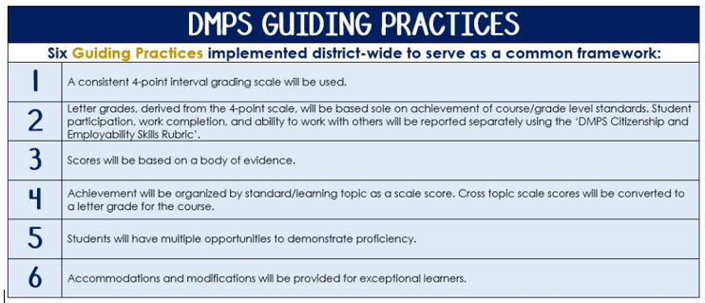
Standards-Referenced Grading Basics
The teacher designs instructional activities and assessments that grow and measure a student’s skills in the elements identified on our topic scales. Each scale features many such skills and knowledges, also called learning targets. These are noted on the scale below with letters (A, B, C) and occur at Levels 2 and 3 of the scale. In the grade book, a specific learning activity could be marked as being 3A, meaning that the task measured the A item at Level 3.

The Body of Evidence in a Process-Based Course
Process-Based SRG is defined as an SRG course design where the same scale recurs throughout the course, but the level of complexity of text and intricacy of task increase over time.

AP Physics 2 cycles students through some topics repeatedly as they progress through the course, with changing content and an increasing complexity of the scientific problem solving, analysis, and expectations throughout.

To account for this, process-based courses like this have their evidence considered in a “Sliding Window” approach. When determining the topic score for any given grading topic, the most recent evidence determines the topic score. Teacher discretion remains a vital part of this determination, but it is hard to overlook evidence from the most recent (and therefore rigorous) assessments.

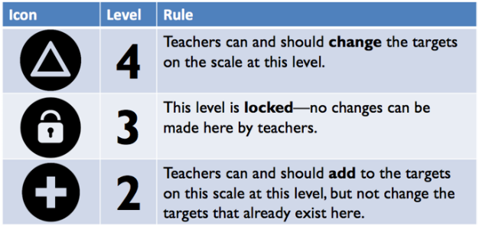
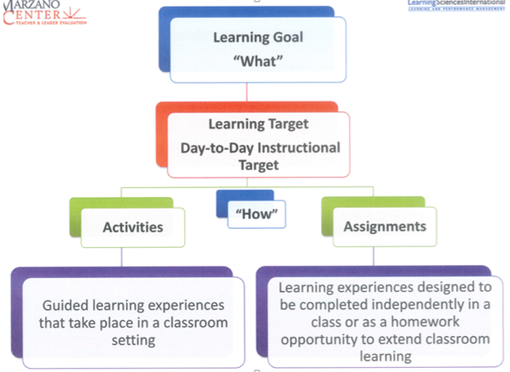

Thermal Physics
Text and Resources

Topic | 4 | 3 | 2
 | In addition to meeting the learning goal, the student demonstrates in-depth inferences and applications that go beyond the goal.

Fluids
Text and Resources

Topic | 4 | 3 | 2
 | In addition to meeting the learning goal, the student demonstrates in-depth inferences and applications that go beyond the goal.

Electrostatics: Forces & Fields
Text and Resources

Topic | 4 | 3 | 2
 | In addition to meeting the learning goal, the student demonstrates in-depth inferences and applications that go beyond the goal.

Electrostatics: Potential & Energy
Text and Resources

Topic | 4 | 3 | 2
 | In addition to meeting the learning goal, the student demonstrates in-depth inferences and applications that go beyond the goal.

Circuits
Text and Resources

Topic | 4 | 3 | 2
 | In addition to meeting the learning goal, the student demonstrates in-depth inferences and applications that go beyond the goal.

Science Practices
Text and Resources

Topic | 4 | 3 | 2
 | In addition to meeting the learning goal, the student demonstrates in-depth inferences and applications that go beyond the goal.

Magnetism
Text and Resources

Topic | 4 | 3 | 2
 | In addition to meeting the learning goal, the student demonstrates in-depth inferences and applications that go beyond the goal.

Optics
Text and Resources

Topic | 4 | 3 | 2
 | In addition to meeting the learning goal, the student demonstrates in-depth inferences and applications that go beyond the goal.

Modern
Text and Resources

Topic | 4 | 3 | 2
 | In addition to meeting the learning goal, the student demonstrates in-depth inferences and applications that go beyond the goal.

Applying Scientific Knowledge
Text and Resources

Topic | 4 | 3 | 2
 | In addition to meeting the learning goal, the student demonstrates in-depth inferences and applications that go beyond the goal.

SRG Scale Score | Topic:  AP-Style Assessments | AP Exam  Score Conversion
4 | In addition to meeting the learning goal, the student demonstrates in-depth inferences and applications that go beyond the goal. | 90-100%
3.5 | Student’s performance reflects exceptional facility with some, but not all Level 4 learning targets. | 80-89%
3  Learning Goal | Student’s performance reflects success on all Level 3 learning targets. | 70-79%
2.5 | Student’s performance reflects success on some, but not all, Level 3 learning targets | 60-69%
2 | Student’s performance reflects success on all Level 2 learning targets. | 50-59%
1.5 | Student’s performance reflects success on some but not all Level 2 learning targets | 40-49%
1 | Student’s performance reflects insufficient progress towards foundational skills and knowledge. | 20-39%

