Errrrrrrrrrrer

8th grade Science Guide
2022-2023
SCI801/802 & SCI8010/8020

http://grading.dmschools.org
http://science.dmschools.org

Foreword
- Foreword includes purpose as well as what can be expected from the guide. (How to use this document…)
- Explains what expectations are for teacher action
How to use this document:
This curriculum guide is not… (determined by specific curriculum phase)
- A lock-step instructional guide detailing exactly when and how you teach.
- Meant to restrict your creativity as a teacher.
- A ceiling of what your students can learn, nor a set of unattainable goals.
Instead, the curriculum guide is meant to be a common vision for student learning and a set of targets and success criteria directed related to grade-level standards by which to measure and report student progress and provide meaningful feedback.
The curriculum guide outlines the learning that is most essential for student success; it is our district’s guaranteed and viable curriculum. The expectation is that every student in our district, regardless of school or classroom, will have access to and learn these targets. As the classroom teacher, you should use the curriculum guide to help you to decide how to scaffold up to the learning targets and extend your students’ learning beyond them.
Within this document, you will find a foundational structure for planning sequential instruction in the classroom which can be supplemented with materials from any number of the linked resources.
Please consider this guide a living and dynamic document, subject to change and a part of a continuous feedback loop.

8th grade: Year at a Glance
Semester 1 | Topic 1: Contact Forces 1 | Topic 2: Contact Forces 2 | Topic 3: Sound Waves | Topic 4: Thermal Energy*
Standards Aligned | MS-PS2-2, MS-PS3-1 | MS-ETS1-3, MS-ETS1-2, MS-PS2-1 | MS-PS4-1, MS-PS4-2 | MS-PS3-3, MS-ETS1-4, MS-ETS1-3
Pacing | 7 weeks |  | 5 weeks
OpenSciEd  Resource | 8.1 Contact Forces |  | 8.2 Sound Waves

Semester 2 | Topic 5: Human Population and Its’ Impact on the Environment* | Topic 6: Natural Selection and Ancestry 1 | Topic 7: Natural Selection and Ancestry 2 | Topic 8: Weather and Climate Systems*
Standards Aligned | MS-ESS3-3, MS-PS1-3, MS-ESS3-4, MS-ESS3-5, MS-ETS1-1 | MS-LS4-1, MS-LS4-4, MS-LS4-6 | MS-LS4-3, MS-LS4-2 | MS-ESS2-4, MS-ESS2-5, MS-ESS2-6
Pacing | 6 weeks | 8 weeks
OpenSciEd  Resource |  | 8.6 Natural Selection and Ancestry |  | 6.3 Weather, Climate & Water Cycling

*These are scales that have been used in the 2021-2022 school year. There is not an OSE module that aligns. This will be adjusted for the 2023-2024 school year.

Anatomy of a Scale
Unit Narrative:
Provide an overview and context of the unit, big understandings, and student experience—including by not limited to vocabulary, inquiry-based questions/concepts, pacing and number of lessons
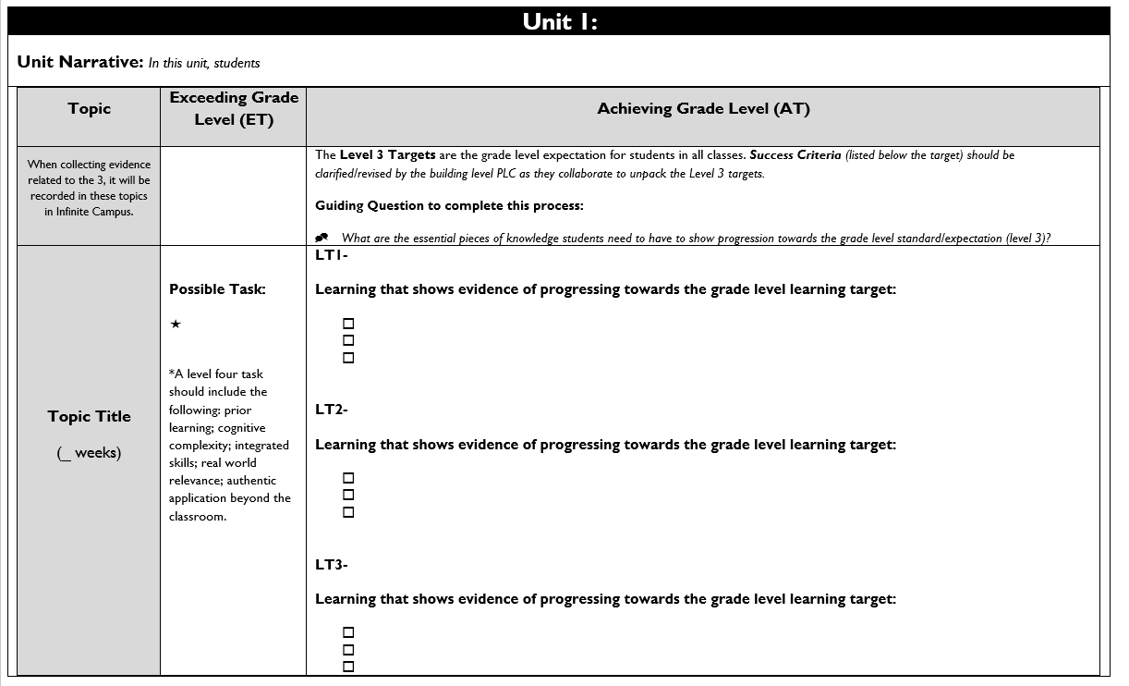

Topic Title:
Named topic in infinite campus, with approximate number of paced weeks
Exceeding Grade Level (ET):
Possible level four task listed including prior learning, cognitive complexity, integrated skills, real world relevance: authentic application beyond the classroom.

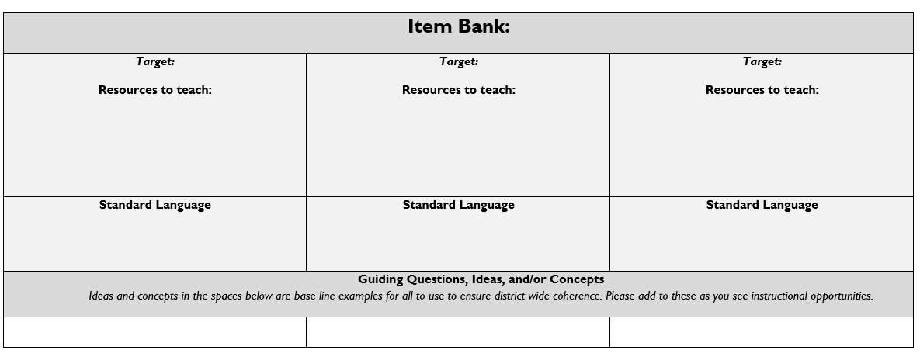
Achieving Grade Level
(AT):
Level 3 targets are listed within the topic scale and are the grade level expectation for students in all classes.
Success Criteria (listed below the target) should be clarified/revised by the building level PLC as they collaborate to unpack the Level 3 targets.

Item Bank:
Linked resources for each learning target. Guiding/Inquiry questions, ideas, and/or concepts are below the base line examples to ensure district wide coherence.

Evidence shows the student ... | Topic Score
Demonstrates proficiency (AT) in all learning targets and success at Level 4 | 4.0
Demonstrates proficiency (AT) in all learning targets with partial success at Level 4 | 3.5
Demonstrates proficiency (AT) in all learning targets | 3.0
Demonstrates proficiency (AT) in at least half of the learning targets | 2.5
Demonstrates some success criteria (PT) toward all learning targets | 2.0
Demonstrates some success criteria (PT) towards some of the learning targets | 1.5
Does not yet meet minimum criteria for the targets. | 1.0
Produces no evidence appropriate to the learning targets at any level | 0
Standards-Referenced Grading Basics
Our purpose in collecting a body of evidence is to:
- Allow teachers to determine a defensible and credible topic score based on a representation of student learning over time.
Start at Level 3 when determining a topic → score.
- Clearly communicate where a student’s learning is based on a topic scale to inform instructional decisions and push student growth.
- Show student learning of targets through multiple and varying points of data
- Provide opportunities for feedback between student and teacher.

Scoring
A collaborative scoring process is encouraged to align expectations of the scale to artifacts collected. Routine use of a collaborative planning and scoring protocol results in calibration and a collective understanding of evidence of mastery. Enough evidence should be collected to accurately represent a progression of student learning as measured by the topic scale. Teachers look at all available evidence to determine a topic score. All topic scores should be defensible and credible through a body of evidence.
Guiding Practices of Standards-Referenced Grading
- A consistent 4-point grading scale will be used.
- Student achievement and behavior will be reported separately.
- Scores will be based on a body of evidence.
- Achievement will be organized by learning topic and converted to a grade at semester’s end.
- Students will have multiple opportunities to demonstrate proficiency.
- Accommodations and modifications will be provided for exceptional learners.

***Only scores of 4, 3.5, 3, 2.5, 2, 1.5, 1, and 0 can be entered as Topic Scores.

Multiple Opportunities
Philosophically, there are two forms of multiple opportunities, both of which require backwards design and intentional planning. One form is opportunities planned by the teacher throughout the unit of study and/or throughout the semester. The other form is reassessment of learning which happens after completing assessment of learning at the end of a unit or chunk of learning.
Students will be allowed multiple opportunities to demonstrate proficiency. Teachers need reliable pieces of evidence to be confident students have a good grasp of the learning topics before deciding a final topic score. To make standards-referenced grading work, the idea of “multiple opportunities” is emphasized. If after these opportunities students still have not mastered Level 3, they may then be afforded the chance to reassess.

Topic 1: Contact Forces 1

Driving Question: Why do things sometimes get damaged when they hit each other?
Contact Forces 1 | Achieving Grade Level (AT)
LT1A- Plan and carry out investigations and analyze and interpret data to figure out that all solid objects behave elastically up to a point and that the forces between objects in a collision are always equal in size and opposite in direction.
- Develop and use free body diagram models to represent the changes in the relative strength of forces on different objects in a collision.
- Develop and use system models to support explanations for how contact forces, including friction and air resistance, cause energy to be transferred from one part of the system to another before, during, and after a collision.

LT1B- Create and use mathematical models to determine how changes in the mass and speed of an object affect the amount of kinetic energy that object has. (MS-PS3-1)
- Analyze data to describe the relationship between kinetic energy and mass as a linear proportional relationship.

Resources
1A  Lesson 4: Task Part 2, 3, 4, 5, and 10 Independent, Dependent and Controlled Variables  Lesson 5: Task Part 8 and 12  Lesson 6: Soccer Assessment-questions 1, 2, and 5  Lesson 10: Baseball Assessment-questions 1, 2, 3  Lesson 15: Cheerleading Assessment Part 1- questions 2a, 2b | 1B  Lesson 6: Soccer Assessment-questions 3, 4, 6, and 7  Lesson 7: Graphing Kinetic Energy Relationships  Lesson 10: Baseball Assessment-questions 4-12

Topic 2: Contact Forces 2

Driving Question: Why do things sometimes get damaged when they hit each other?
Contact Forces 2 | Achieving Grade Level (AT)
LT2A- Analyze data from tests to determine similarities and differences among several design solutions to identify the best characteristics of each that can be combined into a new solution to better meet the criteria for success. (MS-ETS1-3)
- Plan and carry out investigations to determine which cushioning materials reduce peak forces the most in a collision. (MS-PS2-1)
- Using a graphical representation how frequency represents how often the sound source moves in a certain amount of time and the pitch we hear in the sound.
- Carry out investigations and analyze data about how the shape and size of cushioning materials affect force distribution in a cushioning structure.
LT2B - Evaluate competing design solutions using a systematic process to determine how well they meet the criteria and constraints of the problem (MS-ETS1-2)
- Develop macroscopic models of small and microscopic structures of these materials and use these to generate data about how space to deform, contact time in a collision, and peak forces in a collision are related.
- Identify trade-offs, analyze and critique design solutions, and optimize designs solutions using evidence from these investigations to solve different design problems for different stakeholders and different contexts.

Resources
2A  Lesson 11: Pre-Assessment-Protection Device Design  Lesson 12: Task part 5-Compare Class Data  Lesson 15: Cheerleading Assessment | 2B  Lesson 12: Task part 9- Construct Individual Material Explanation  Lesson 14: Protective Device Redesign and Stakeholder feedback  Lesson 15: Cheerleading Assessment Part 1-questions 1a, 1b  Lesson 15: Cheerleading Assessment Part 2  Lesson 16: Investor Pitch Presentation

Topic 3: Sound Waves

Driving Question: How can a sound move something?
Sound Waves | Achieving Grade Level (AT)
LT3A- Use mathematical representations (data) of a simple wave model to describe how the amplitude of a wave is related to the energy of a wave. (MS-PS4-1)
- Using a graphical representation explain how amplitude is the distance the object moves from its starting point, which is related to the strength of the force applied and the object’s loudness.
- Using a graphical representation how frequency represents how often the sound source moves in a certain amount of time and the pitch we hear in the sound.
- Construct an argument using evidence from graphs to support an explanation for which patterns of frequency and amplitude of a wave are indicators of attributes of sounds that we can hear.

LT3B- Develop and use a model to describe unobservable parts (particles) of the system and how they would interact with one another in any state of matter to transfer energy from a vibrating sound source through collisions with one another across a medium. (MS-PS4-2)
- Develop a model of vibration that captures important ideas about how changes in the frequency and amplitude of the vibrations that can explain these different characteristics of sounds
- Use a model to explain how a force causes the sound source to vibrate (effect) and make a sound even if we cannot see it.

Resources
3A  Lesson 4: Task part 7, monitor progress tracker (formative)  Lesson 5: Exit Ticket, Analyzing Graphs of Sounds Source Vibrations  Lesson 6: Harp Assessment, question 5  Lesson 13: Sonic Fire Extinguisher Assessment, questions 1-3 | 3B  Lesson 1: Initial model (pre-assessment)  Lesson 2: Task Part 6, instrument modeling (formative)  Lesson 6: Harp Assessment, questions 1-4 with model rubric  Lesson 11: Revised model with modeling rubric  Lesson 14: Unit assessment, questions 1-3

Topic 4: Thermal Energy

Driving Question: How can we manage thermal energy?
Thermal Energy | Achieving Grade Level (AT)
LT4A- Apply scientific principles to design and construct a device that either minimizes or maximizes thermal energy transfer (MS-PS3-3)
- Compare and contrast conduction and insulation
- Describe how thermal energy transfers
- Cite evidence for constraints in the design of modeling, planning and appropriate materials.

LT4B- Test and evaluate the device to determine its ability to either minimize or maximize thermal energy transfer based on the established criteria and constraints. (MS-PS3-3)
- Measure temperature
- Calculate rate of temperature change
- Collect and organize data
- State a claim

Topic 5: Human Population and Its’ Impact on the Environment

Driving Question: How does a growing population impact the environment?
Human Population and Its’ Impact on the Environment | Achieving Grade Level (AT)
LT5A- Apply scientific principles to design a method for monitoring and minimizing human impact on the environment. (MS-ESS3-3)
- Proposes a design to reduce human impacts
- Describes constraints and criteria for the designed solution
- Describe how well the solution(s) meets the criteria and constraints and limitations

LT5B- Construct an argument supported by evidence for how increases in human population and per-capita consumption of natural resources impact Earth’s systems. (MS-ESS3-4)
- Research and Construct an Argument: Human Population Changes over a time period, Consumption of Natural Resources, Claim-Evidence-Reasoning regarding Human Impact on Earth Systems

LT35C- Gather and make sense of information to describe that synthetic materials come from natural resources and impact society. (MS-PS1-3)
- Specify how synthetic materials come from Natural Resources
- Describe natural resources
- Cite evidence for how society has an impact on synthetic materials

LT35D- Ask questions to clarify evidence of the factors that have caused the change in global temperatures over the past century. (MS-ESS3-5)
- Identify temperature patterns over a given time period
- Compose open ended testable questions from global climate factors data

Topic 6: Natural Selection and Ancestry 1

Driving Question: How could things living today be connected to the things that lived long ago?
Natural Selection and Ancestry 1 | Achieving Grade Level (AT)
LT6A- Construct an argument supported by evidence and reasoning to support an explanation for whether the types of things that lived long ago are ancestors to the modern organisms we see today. (MS-LS4-1)
- Define the fossil record.
- Interpret fossil record for patterns.

LT6B- Construct an explanation based on evidence that describes how genetic variations of traits in a population increase some individuals’ probability of surviving and reproducing in a specific environment. (MS-LS4-4)
- Describe how mutations in an individual may result in genetic variation in a population.
- Describe the cause and effect relationship between an organism’s survival and its inheritance of different traits.

LT6C- Construct explanations based on evidence collected from a simulated environment and models for how small changes in an environment can cause large changes in a population over time. (MS-LS4-6)
- Gather evidence in a simulated environment.
- Make connections between data that was gathered and science ideas.

Topic 7: Natural Selection and Ancestry 2

Driving Question: How could things living today be connected to the things that lived long ago?
Natural Selection and Ancestry 2 | Achieving Grade Level (AT)
LT7A- Apply scientific ideas to construct an explanation for the anatomical similarities and differences among modern organisms and between modern and fossil organisms to infer evolutionary relationships. (MS-LS4-2)
- Compare differences between modern living organisms vs. fossilized organisms.
- Explain where ancient species went

LT7B- Outline an argument for how new model ideas or application of old models could explain patterns in sketches of the physical structures apparent in different species at different stages of development emphasizing new ideas about how different species may be connected. (MS-LS4-3)
- Analyze sketched of different types of animals at different stages developmentally.
- Identify similarities in physical structures that are not evident in fully formed anatomy

Topic 8: Weather, Climate & Systems
Driving Question: Why does a lot of hail, rain, or snow fall at sometimes and not others?
Weather, Climate & Systems | Achieving Grade Level (AT)
LT8A- Develop a model to describe the cycling of water through Earth’s systems driven by energy from the sun and the force of gravity. (MS-ESS2-4)
- Explain how characteristics of surface materials impact energy flowing into and out of the atmospheric gasses (including water vapor).
- Model how atmospheric gases (including water vapor) experience energy flows shown in temperature changes affecting phase change, density and motions of air parcels.
LT8B- Collect data to provide evidence for how the motions and complex interactions of air masses result in changes in weather conditions. (MS-ESS2-5)
- Collect evidence through experiments to determine factors that affect lift for clouds, storms, and forms of precipitation.
- Analyze large scale weather data/maps to predict large air parcel behaviors and interactions.
LT8C - Develop and use a model to describe how unequal heating and rotation of the Earth cause patterns of atmospheric and oceanic circulation that determine regional climates. (MS-ESS2-6)
- Explain mechanisms which drive weather systems and world-wide circulations patterns in temperature, precipitation, and air and ocean movement.
- Diagram cause and effect relationships of solar energy to land, oceans and air creating regional climates.

