Errrrrrrrrrrer

7th grade Science Guide
2022-2023
SCI701/702 & SCI7010/7020

http://grading.dmschools.org
http://science.dmschools.org

Foreword
How to use this document:
This curriculum guide is not…
- A lock-step instructional guide detailing exactly when and how you teach.
- Meant to restrict your creativity as a teacher.
- A ceiling of what your students can learn, nor a set of unattainable goals.
Instead, the curriculum guide is meant to be a common vision for student learning and a set of targets and success criteria directed related to grade-level standards by which to measure and report student progress and provide meaningful feedback.
The curriculum guide outlines the learning that is most essential for student success; it is our district’s guaranteed and viable curriculum. The expectation is that every student in our district, regardless of school or classroom, will have access to and learn these targets. As the classroom teacher, you should use the curriculum guide to help you to decide how to scaffold up to the learning targets and extend your students’ learning beyond them.
Within this document, you will find a foundational structure for planning sequential instruction in the classroom which can be supplemented with materials from any number of the linked resources.
Please consider this guide a living and dynamic document, subject to change and a part of a continuous feedback loop.

7th grade Science: Year at a Glance
Semester 1 | Topic 1: Metabolic Reactions | Topic 2: Matter Cycling and Photosynthesis | Topic 3: Ecosystems Dynamics 1 | Topic 4: Ecosystems Dynamics 2
Standards Aligned | MS-LS1-3, MS-LS1-7, MS-PS1-2, MS-PS1-1, MS-LS1-5 | MS-LS1-6, MS-LS2-2, MS-PS1-3, MS-LS1-2 | MS-LS2-1, MS-LS2-4, MS-LS2-2 | MS-LS2-5, MS-ESS3-3, MS-ETS1-1
Pacing | 6 weeks | 6 weeks
OpenSciEd Resource | 7.3 Metabolic Reactions | 7.4 Matter Cycling & Photosynthesis | 7.5 Ecosystems Dynamics | 7.5 Ecosystem Dynamics

Semester 2 | Topic 5: Earth’s Resources and Human Impact 1 | Topic 6: Earth’s Resources and Human Impact 2 | Topic 7: Weather, Climate & Systems** | Topic 8: Extinction and Geological Time*
Standards Aligned | MS-ESS3-1, MS-ESS3-5, MS-ESS3-3 | MS-ESS3-4, MS-ETS1-2 | MS-ESS2-4, MS-ESS2-5, MS-ESS2-6 | MS-ESS1-4
Pacing
OpenSciEd Resource | 7.6 Earth’s Resources and Human Impact | 7.6 Earth’s Resources and Human Impact | 6.3 Weather Climate & Systems

*These are scales that have been used in the 2021-2022 school year. There is not an OSE module that aligns. This will be adjusted for the 2023-2024 school year.
**Only be taught in 7th grade for the 2022-2023 school year.

Anatomy of a Scale
Unit Narrative:
Provide an overview and context of the unit, big understandings, and student experience—including by not limited to vocabulary, inquiry-based questions/concepts, pacing and number of lessons
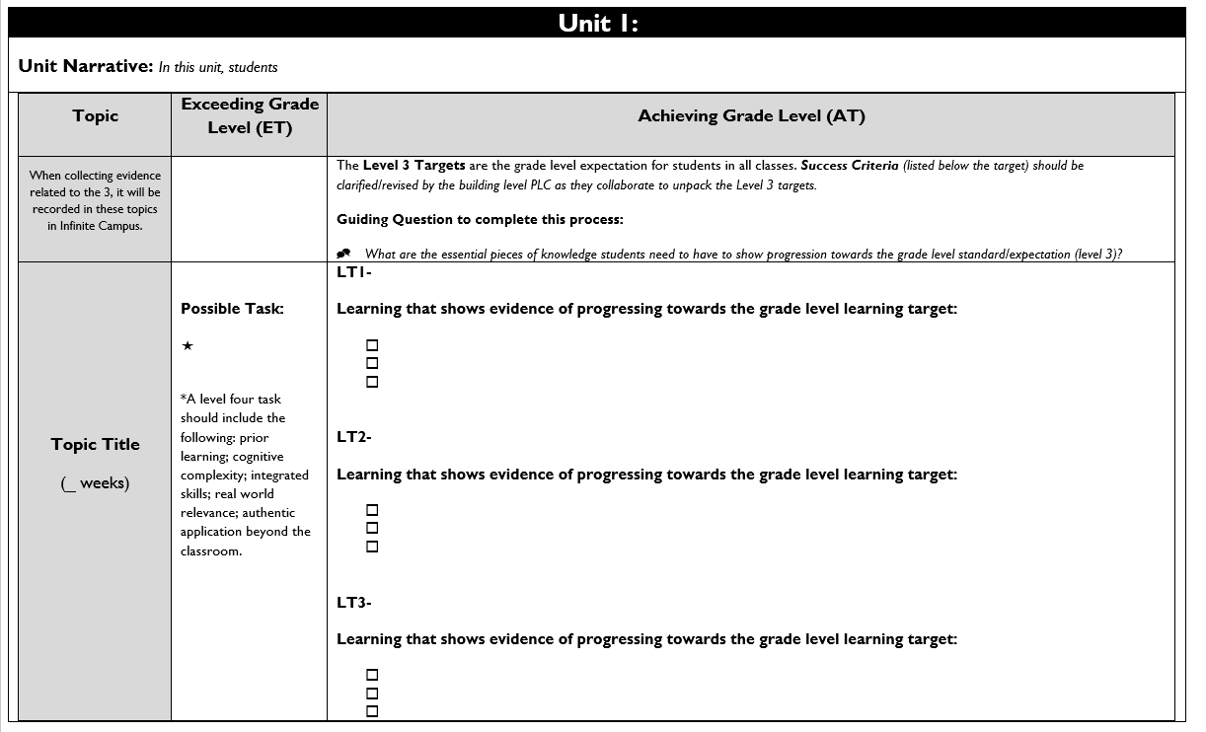

Topic Title:
Named topic in infinite campus, with approximate number of paced weeks
Exceeding Grade Level (ET):
Possible level four task listed including prior learning, cognitive complexity, integrated skills, real world relevance: authentic application beyond the classroom.

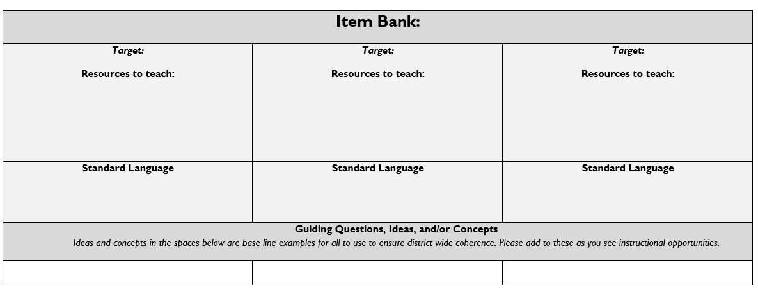
Achieving Grade Level
(AT):
Level 3 targets are listed within the topic scale and are the grade level expectation for students in all classes.
Success Criteria (listed below the target) should be clarified/revised by the building level PLC as they collaborate to unpack the Level 3 targets.

Item Bank:
Linked resources for each learning target. Guiding/Inquiry questions, ideas, and/or concepts are below the base line examples to ensure district wide coherence.

Evidence shows the student ... | Topic Score
Demonstrates proficiency (AT) in all learning targets and success at Level 4 | 4.0
Demonstrates proficiency (AT) in all learning targets with partial success at Level 4 | 3.5
Demonstrates proficiency (AT) in all learning targets | 3.0
Demonstrates proficiency (AT) in at least half of the learning targets | 2.5
Demonstrates some success criteria (PT) toward all learning targets | 2.0
Demonstrates some success criteria (PT) towards some of the learning targets | 1.5
Does not yet meet minimum criteria for the targets. | 1.0
Produces no evidence appropriate to the learning targets at any level | 0
Standards-Referenced Grading Basics
Our purpose in collecting a body of evidence is to:
- Allow teachers to determine a defensible and credible topic score based on a representation of student learning over time.
Start at Level 3 when determining a topic → score.
- Clearly communicate where a student’s learning is based on a topic scale to inform instructional decisions and push student growth.
- Show student learning of targets through multiple and varying points of data
- Provide opportunities for feedback between student and teacher.

Scoring
A collaborative scoring process is encouraged to align expectations of the scale to artifacts collected. Routine use of a collaborative planning and scoring protocol results in calibration and a collective understanding of evidence of mastery. Enough evidence should be collected to accurately represent a progression of student learning as measured by the topic scale. Teachers look at all available evidence to determine a topic score. All topic scores should be defensible and credible through a body of evidence.
Guiding Practices of Standards-Referenced Grading
- A consistent 4-point grading scale will be used.
- Student achievement and behavior will be reported separately.
- Scores will be based on a body of evidence.
- Achievement will be organized by learning topic and converted to a grade at semester’s end.
- Students will have multiple opportunities to demonstrate proficiency.
- Accommodations and modifications will be provided for exceptional learners.

***Only scores of 4, 3.5, 3, 2.5, 2, 1.5, 1, and 0 can be entered as Topic Scores.

Multiple Opportunities
Philosophically, there are two forms of multiple opportunities, both of which require backwards design and intentional planning. One form is opportunities planned by the teacher throughout the unit of study and/or throughout the semester. The other form is reassessment of learning which happens after completing assessment of learning at the end of a unit or chunk of learning.
Students will be allowed multiple opportunities to demonstrate proficiency. Teachers need reliable pieces of evidence to be confident students have a good grasp of the learning topics before deciding a final topic score. To make standards-referenced grading work, the idea of “multiple opportunities” is emphasized. If after these opportunities students still have not mastered Level 3, they may then be afforded the chance to reassess.

Topic 1: Metabolic Reactions
Driving Question: How do things inside our bodies work together to make us feel the way we do?
Metabolic Reactions  6 weeks | Achieving Grade Level (AT)
LT1A- Develop and use a model to explain how different subsystems of the body work together to provide cells what they need to function. (MS-LS1-3)
- Create a model incorporating the appropriate components and interactions associated with a typical digestive system.
- Use the model to explain how various subsystems in a healthy digestive system interact to move food through a series of chemical reactions to break down large food molecules.
LT1B- Construct an argument from evidence supported by scientific reasoning for how a healthy digestive system rearranges matter through chemical reactions and absorbs food as compared to an unhealthy system.
- Argument includes a claim and an associated justification that is based on evidence or empirical data.
- Argument connects scientific principles or ideas to each piece of evidence and the claim.
- Argument includes a rebuttal that critiques the evidence of possible alternative claims.
LT1C- Develop and use a model to explain how food is rearranged through chemical reactions, forming new molecules that support growth and/or release energy as this matter moves through an organism. (MS-LS1-7)
- Analyze and interpret data on the properties of substances before and after the substances interact to determine if a chemical reaction has occurred. (MS-PS1-2)
- Describe the atomic composition of simple food molecules and complex structures within the model. (MS-PS1-1)
- Create a model incorporating the appropriate components and interactions outlined in the unit storyline.
LT1D- Construct a scientific explanation based on evidence for how environmental factors, such as food intake, influence the growth of animals. (MS-LS1-5)
- Develop an explanation the connects the given phenomenon to a scientific idea and environmental factors
- Identify and describe evidence necessary for constructing the explanation
- Use reasoning to connect the evidence and support an explanation for the phenomenon involving environment influences and organism growth.

Resources
1A  Lesson 1: Initial model (pre-assessment)  Lesson 3: progress trackers  Lesson 7: Task Parts 1, 2, 3 Monitor the “Got to have it” checklist and the development of small group models. | 1B  Lesson 7: Task Part 9 Student Assessment  Lesson 8 Part 3: argue from evidence what’s causing M’Kenna’s symptoms
1C  Lesson 13: Task Part 2 monitor the creation of small group models  Lesson 15: Brown Bear Assessment | 1D  Lesson 13: Task Part 7 student develop and individual explanation based off the class consensus model  Lesson 15: Brown Bear Assessment

Topic 2: Matter Cycling & Photosynthesis
Driving Question: Where does food come from and where does it go next?
Matter Cycling & Photosynthesis | Achieving Grade Level (AT)
LT2A- Construct a scientific explanation based on evidence for the role of photosynthesis in the cycling of matter and flow of energy into and out of organisms (MS-LS1-6)
- Develop a model to track the inputs and outputs of plants and incorporates how parts of the plant cell contribute to photosynthesis. (MS-LS1-2)
- Carry out experiments to figure out how leaves and seeds interact with the gases in the air around them in the light and the dark
- Develop and evaluate arguments from evidence to figure out where plants are getting the energy and matter, they need to live.
- Construct an explanation for the central role of photosynthesis in all food production, including synthetic foods (MS-PS1-3)
LT2B- Develop a model to describe the cycling of matter and flow of energy among living and nonliving parts of an ecosystem. (MS-LS2-3)
- Obtain and communicate information to explain how matter gets from living things that have died back into the system through processes done by decomposers.
- Develop and use a model to explain that the major atoms that make up food (carbon, hydrogen, and oxygen) are continually recycled between living and nonliving parts of a system

Resources
2A  Lesson 4: Task parts 2-6  Lesson 8: Midpoint Assessment  Lesson 11: Maple Tree Assessment  Lesson 15: Whale Fall Assessment, part 2, questions 1-3 | 2B  Lesson 13: Obtaining and Communicating Information Checklist  Lesson 14: Task part 5 - progress tracker, Task part 7 – The Story of a Food Atom  Lesson 15: Whale Fall Assessment, part 1, questions 1-3

Topic 3: Ecosystem Dynamics 1

Driving Question: How does changing an ecosystem affect what lives there?
Ecosystems Dynamics 1 | Achieving Grade Level (AT)
LT3A- Analyze and interpret data to provide evidence for the effects of resource availability on organisms and populations of organisms in an ecosystem. (MS-LS2-1)
- Plan and carry out simulated computer model investigations to examine what orangutans need to support healthy populations.
- Engage in mathematical reasoning and computational thinking to determine the area of forest required by orangutans and how resource availability impacts orangutan populations.

LT3B- Construct an argument supported by empirical evidence that changes to physical or biological components of an ecosystem affect populations. (MS-LS2-4)
- Develop a claim for a specific phenomenon that includes the idea that changes to physical or biological components of an ecosystem can affect the populations living there.
- Identify and describe the evidence needed for supporting the claim
- Critique and evaluate the evidence by describing what evidence supports the claim and what evidence could support alternative claims.
- Use reasoning to connect the evidence to the claim and construct an oral or written argument.

LT3C- Construct an explanation that predicts patterns of interactions among organisms across multiple ecosystems. (MS-LS2-2)
- Model competition for available resources within and between populations, and model other interactions (e.g., predation, mutually-beneficial interactions, etc.) between populations.
- Use models to predict and test how various disruptions would impact more or less biodiverse systems.

Topic 4: Ecosystem Dynamics 2

Driving Question: How does changing an ecosystem affect what lives there?
Ecosystems Dynamics 2 | Achieving Grade Level (AT)
LT4A- Evaluate competing design solutions for maintaining biodiversity and ecosystem services. (MS-LS2-5)
- Obtain information about alternative farming approaches and ecosystem services in comparison to monocrop farming and apply these ideas to the design of an oil palm farm system that supports both orangutans and farmers.
- Construct arguments that more biodiverse plant communities support other living things, particularly when there is a disruption.
LT4B- Apply scientific principles to design a method for monitoring and minimizing a human impact on the environment. (MS-ESS3-3)

LT4C- Define the criteria and constraints of a design problem with sufficient precision to ensure a successful solution, taking into account relevant scientific principles and potential impacts on people and the natural environment that may limit possible solutions. (MS-ETS1-1)

Topic 5: Earth’s Resources and Human Impact 1

Driving Question: How do changes in the Earth’s system impact our communities and what can we do about it?
Earth’s Resources and Human Impact 1 | Achieving Grade Level (AT)
LT5A- Construct a scientific explanation based on evidence for how the uneven distributions of Earth’s mineral, energy, and groundwater resources are the result of past and current geoscience processes. (MS-ESS3-1)
- Construct an explanation for how increased temperatures can cause changes to a community’s water resources.

LT5B- Ask questions to clarify evidence of the factors that have caused the rise in global temperatures over the past century. (MS-ESS3-5)
- Analyze and interpret data that indicate long-term climate variables (temperature and precipitation) are changing in communities.

LT5C - Apply scientific principles to design a method for monitoring and minimizing a human impact on the environment. (MS-ESS3-3)
- Develop and use models to explain how changing variables in Earth’s water and carbon systems are impacting human communities that depend on those systems.

Topic 6: Earth’s Resources and Human Impact 2

Driving Question: How do changes in the Earth’s system impact our communities and what can we do about it?
Earth’s Resources and Human Impact 2 | Achieving Grade Level (AT)
LT6A- Construct an argument supported by evidence for how increases in human population and per-capita consumption of natural resources impact Earth’s systems. (MS-ESS3-4)
- Argue from evidence that rising temperatures result from an imbalance in Earth’s carbon system.

LT6B- Evaluate competing design solutions using a systematic process to determine how well they meet the criteria and constraints of the problem. (MS-ETS1-2)
- Define the problem as an imbalance in Earth’s carbon system due to greenhouse gas accumulation, with no easy solutions to quickly fix it.
- Evaluate a variety of solutions based on how well they meet the criteria of reducing the carbon imbalance given the many societal constraints students identified
- Communicate about community resilience designed to account for stakeholders’ needs while also correcting carbon imbalances and adapting to current changes experienced in the community.

Topic 7: Weather, Climate & Systems
Driving Question: Why does a lot of hail, rain, or snow fall at sometimes and not others?
Weather, Climate & Systems | Achieving Grade Level (AT)
LT7A- Develop a model to describe the cycling of water through Earth’s systems driven by energy from the sun and the force of gravity. (MS-ESS2-4)
- Explain how characteristics of surface materials impact energy flowing into and out of the atmospheric gasses (including water vapor).
- Model how atmospheric gases (including water vapor) experience energy flows shown in temperature changes affecting phase change, density and motions of air parcels.
LT7B- Collect data to provide evidence for how the motions and complex interactions of air masses result in changes in weather conditions. (MS-ESS2-5)
- Collect evidence through experiments to determine factors that affect lift for clouds, storms, and forms of precipitation.
- Analyze large scale weather data/maps to predict large air parcel behaviors and interactions.
LT7C - Develop and use a model to describe how unequal heating and rotation of the Earth cause patterns of atmospheric and oceanic circulation that determine regional climates. (MS-ESS2-6)
- Explain mechanisms which drive weather systems and world-wide circulations patterns in temperature, precipitation, and air and ocean movement.
- Diagram cause and effect relationships of solar energy to land, oceans and air creating regional climates.

Topic 8: Extinction and Geological Time
Driving Question: How does understanding earth’s past help us better understand Earth’s future?
Extinction and Geological Time | Achieving Grade Level (AT)
LT8A- Construct a scientific explanation based on the evidence from rock strata for how the geologic time scale is used to organize Earth’s 4.6-billion-year-old history. (MS-ESS1-4)
- Make observations about the types of rocks and how they are formed
- Describe how the rock cycle impacts the formation of the layers of the earth and fossils
- Use index fossils and the types of rock layers to identify the age of a layer of rock

