Errrrrrrrrrrer
6th grade Science Guide
2022-2023

6th grade Science Guide
2022-2023
SCI601/602 & SCI6010/6020

http://grading.dmschools.org
http://science.dmschools.org

Foreword
How to use this document:
This curriculum guide is not…
- A lock-step instructional guide detailing exactly when and how you teach.
- Meant to restrict your creativity as a teacher.
- A ceiling of what your students can learn, nor a set of unattainable goals.
Instead, the curriculum guide is meant to be a common vision for student learning and a set of targets and success criteria directed related to grade-level standards by which to measure and report student progress and provide meaningful feedback.
The curriculum guide outlines the learning that is most essential for student success; it is our district’s guaranteed and viable curriculum. The expectation is that every student in our district, regardless of school or classroom, will have access to and learn these targets. As the classroom teacher, you should use the curriculum guide to help you to decide how to scaffold up to the learning targets and extend your students’ learning beyond them.
Within this document, you will find a foundational structure for planning sequential instruction in the classroom which can be supplemented with materials from any number of the linked resources.
Please consider this guide a living and dynamic document, subject to change and a part of a continuous feedback loop.

6th grade Science: Year at a Glance
Semester 1 | Topic 1: Light & Matter | Topic 2: Thermal Energy 1 | Topic 3: Thermal Energy 3 | Topic 4: Weather, Climate & Water Cycling
Standards Aligned | MS-PS4-2, MS-LS1-8 | MS-PS1-4, MS-PS3-5 | MS-PS3-3, MS-PS3-4, MS-ETS1-4 | MS-ESS2-4, MS-ESS2-5, MS-ESS2-6
Pacing | 4 weeks | 8 weeks
OpenSciEd Resource | 6.1 Light & Matter | 6.2 Thermal Energy | 6.2 Thermal Energy | 6.3 Weather, Climate & Water Cycling

Semester 2 | Topic 5: Plate Tectonics & Rock Cycling | Topic 6: Natural Hazards | Topic 7 Cells & Systems
Standards Aligned | MS-ESS1-4, MS-ESS2-1, MS-ESS2-2, MS-ESS2-3 | MS-ESS2-3, MS-PS4-3, MS-ETS1-1, MS-ETS1-2 | MS-LS1-1, MS-LS1-2, MS-LS1-3, MS-LS1-8
Pacing | 6 weeks | 4 weeks | 6 weeks
OpenSciEd Resource | 6.4 Plate Tectonics & Rock Cycling | 6.5 Natural Hazards | 6.6 Cells & Systems

Evidence shows the student can... | Topic Score
Demonstrates proficiency (AT) in all learning targets from Level 3 & Level 4 | 4.0
Demonstrates proficiency (AT) in all learning targets from Level 3 with partial success at Level 4 | 3.5
Demonstrates proficiency (AT) in all learning targets from Level 3 | 3.0
Demonstrates proficiency (AT) in at least half of the Level 3 learning targets | 2.5
Demonstrates some foundational knowledge (PT) toward all Level 3 targets | 2.0
Demonstrates some foundational knowledge (PT) of some of the Level 3 learning target or standard | 1.5
Does not meet minimum criteria for the standard or target. | 1.0
Produces no evidence appropriate to the learning targets at any level (Is missing for one or more targets) | 0
* foundational knowledge is defined by the success criteria for the learning targets or standards.

Standards-Referenced Grading Basics
Our purpose in collecting a body of evidence is to:
• Allow teachers to determine a defensible and credible topic score based on a representation of student learning over time.
Start at Level 3 when determining a topic → score.
• Clearly communicate where a student’s learning is based on a topic scale to inform instructional decisions and push student growth.
• Show student learning of Level 3 targets through multiple and varying points of data
• Provide opportunities for feedback between student and teacher.
Scoring
A collaborative scoring process is encouraged to align expectations of the scale to artifacts collected. Routine use of a collaborative planning and scoring protocol results in calibration and a collective understanding of evidence of mastery. Enough evidence should be collected to accurately represent a progression of student learning as measured by the topic scale. Teachers look at all available evidence to determine a topic score. All topic scores should be defensible and credible through a body of evidence.
***Only scores of 4, 3.5, 3, 2.5, 2, 1.5, 1, and 0 can be entered as Topic Scores.
Guiding Practices of Standards-Referenced Grading
- A consistent 4-point grading scale will be used.
- Student achievement and behavior will be reported separately.
- Scores will be based on a body of evidence.
- Achievement will be organized by learning topic and converted to a grade at semester’s end.
- Students will have multiple opportunities to demonstrate proficiency.
- Accommodations and modifications will be provided for exceptional learners.

Multiple Opportunities
Philosophically, there are two forms of multiple opportunities, both of which require backwards design and intentional planning. One form is opportunities planned by the teacher throughout the unit of study and/or throughout the semester. The other form is reassessment of learning which happens after completing assessment of learning at the end of a unit or chunk of learning.
Students will be allowed multiple opportunities to demonstrate proficiency. Teachers need reliable pieces of evidence to be confident students have a good grasp of the learning topics before deciding a final topic score. To make standards-referenced grading work, the idea of “multiple opportunities” is emphasized. If after these opportunities students still have not mastered Level 3, they may then be afforded the chance to reassess.

Anatomy of a Scale
Unit Narrative:
Provide an overview and context of the unit, big understandings, and student experience—including by not limited to vocabulary, inquiry-based questions/concepts, pacing and number of lessons
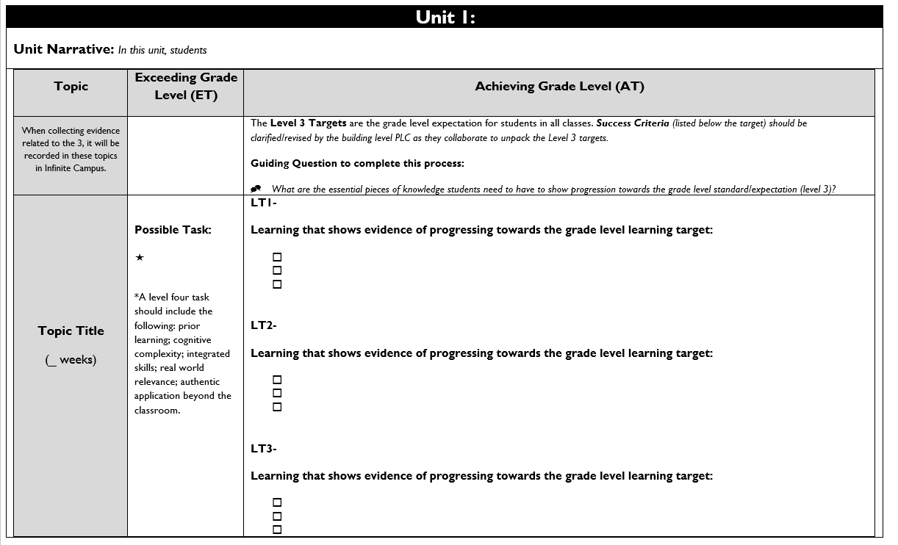

Topic Title:
Named topic in infinite campus, with approximate number of paced weeks
Exceeding Grade Level (ET):
Possible level four task listed including prior learning, cognitive complexity, integrated skills, real world relevance: authentic application beyond the classroom.

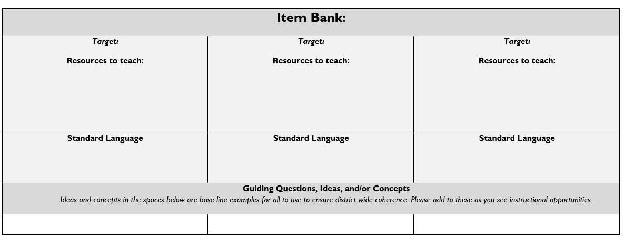
Achieving Grade Level
(AT):
Level 3 targets are listed within the topic scale and are the grade level expectation for students in all classes.
Success Criteria (listed below the target) should be clarified/revised by the building level PLC as they collaborate to unpack the Level 3 targets.

Item Bank:
Linked resources for each learning target. Guiding/Inquiry questions, ideas, and/or concepts are below the base line examples to ensure district wide coherence.

Topic 1: Light & Matter

Driving Question: Why do we sometimes see different things when looking at the same object?
Light & Matter  4 weeks | Achieving Grade Level (AT)
LT1A- Develop and use a model to describe that path of light are reflected and transmitted through various materials. (MS-PS4-2)
- Identify the components of a system and explain the interactions.
- Describe the relationship between the components and how the light interact with materials.
- Use their model to make sense of different phenomenon

LT1B- Synthesize information that perspective changes based on the amount of light. (MS-LS1-8)
- Explain how light changes when it travels through different materials.
- Explain how the shape and composition of the lens causes the path of light to change directions (refract) before reaching the retina at the back of the eye.

Resources
1A  Lesson 7: Summative Assessment*  Lesson 8: Optional Assessment | 1B  Lesson 8: Summative Assessment

Topic 2: Thermal Energy 1

Driving Question: How can containers keep stuff from warming up or cooling down?
Thermal Energy 1 | Achieving Grade Level (AT)
LT2A- Develop a model that predicts and describes changes in particle motion, temperature, and state of a pure substance when thermal energy is added or removed. (MS-PS1-4)
- Identify the components of a system and explain the interactions.
- Describe the relationship between the components and how the waves interact with materials.
- Use their model to make sense of different phenomenon

LT2B – Construct, use, and present arguments to support the claim that when the motion of an object changes, energy is transferred to or from the object. (MS-PS3-5)
- Make a claim based on a phenomenon that when kinetic energy of an object changes, energy is transferred.
- Describe evidence and how it supports the claim.

Resources
2A  Lesson 1: Initial model (pre-assessment)  Lesson 3: Task part 3, examine student notebook for model  Lesson 6: Effects of Lid Design Assessment, questions 3-5  Lesson 14: Icing Injuries Assessment, questions 4-6 | 2B  Lesson 5: Cold Lemonade Assessment (supports argument development)  Lesson 6: Effects of Lid Design Assessment, questions 3-5  Lesson 14: Icing Injuries Assessment, questions 1-3  Lesson 18: Disaster Blanket Assessment, questions 1 and 3

Topic 3: Thermal Energy 2

Driving Question: How can containers keep stuff from warming up or cooling down?
Thermal Energy 2 | Achieving Grade Level (AT)
LT3A- Plan an investigation to determine the relationships among the energy transferred, the type of matter, the mass and the change in the average kinetic energy of the particles as measured by the temperature of the sample (MS-PS3-4).
- Plan and carry out investigations to systematically test the different parts of the cup system, tracking the flow of matter and energy into or out of the cup system.
- Revise their models to include factors that minimize energy transfer by reducing the absorption of light and decreasing the opportunities for particle collisions

LT3B- Apply scientific principles and the engineering design cycle to design, construct, and test a device that minimizes thermal energy transfer. (MS-PS3-3, MS-ETS1-4)
- Apply learning about cup features that can slow energy transfer to design and build a cup system to keep a drink cold.
- Test the cup system to determine its ability to minimize the flow of thermal energy, using the rate of temperature change as a measure of success.
- Incorporate knowledge of thermal energy transfer and the results of the testing to evaluate the design systematically against the criteria and constraints

Resources
3A  Lesson 2: Task parts 3 and 4  Lesson 3: Task part 6, examine student investigation plan  Lesson 6: Effects of Lid Design Assessment | 3B  Lesson 18: Disaster Blanket Assessment, questions 2

Topic 4: Weather, Climate & Systems
Driving Question: Why does a lot of hail, rain, or snow fall at sometimes and not others?
Weather, Climate & Systems | Achieving Grade Level (AT)
LT4A- Develop a model to describe the cycling of water through Earth’s systems driven by energy from the sun and the force of gravity. (MS-ESS2-4)
- Explain how characteristics of surface materials impact energy flowing into and out of the atmospheric gasses (including water vapor).
- Model how atmospheric gases (including water vapor) experience energy flows shown in temperature changes affecting phase change, density and motions of air parcels.
LT4B- Collect data to provide evidence for how the motions and complex interactions of air masses result in changes in weather conditions. (MS-ESS2-5)
- Collect evidence through experiments to determine factors that affect lift for clouds, storms, and forms of precipitation.

- Analyze large scale weather data/maps to predict large air parcel behaviors and interactions.
LT4C - Develop and use a model to describe how unequal heating and rotation of the Earth cause patterns of atmospheric and oceanic circulation that determine regional climates. (MS-ESS2-6)
- Explain mechanisms which drive weather systems and world-wide circulations patterns in temperature, precipitation, and air and ocean movement.
- Diagram cause and effect relationships of solar energy to land, oceans and air creating regional climates.

Topic 5: Plate Tectonics & Rocky Cycling

Driving Question: What causes Earth’s surface to change?
Plate Tectonics & Rock Cycling | Achieving Grade Level (AT)
LT5A- Construct a scientific explanation based on evidence from rock strata for how the geologic time scale is used to organize Earth's 4.6-billion-year-old history. (MS-ESS1-4)
- Analyze rock layers and use mathematical reasoning to determine the relative age of material.
- Analyze rock strata and fossil data to determine the location of past continents from a specified time period
LT5B- Develop a model to describe the cycling of Earth's materials and the flow of energy that drives this process. (MS-ESS2-1)
- Describe the impact of erosional forces and their energy source on Earth’s surface and the cycling of materials.
- Describe how materials are cycled in Earth’s interior and connections to surface processes (include energy sources and temporal and spatial scales)
LT5C- Construct an explanation based on evidence for how geoscience processes have changed Earth's surface at varying time and spatial scales. (MS-ESS2-2)
- Analyze multiple sources of data and information (e.g., large data sets on maps, cross-section graphs, text, tables, and labs) over multiple scales to identify patterns.
- Explain the processes that build up and wear down Earth’s surface.
LT5D- Analyze and interpret data on the distribution of fossils and rocks, continental shapes, and seafloor structures to provide evidence of the past plate motions. (MS-ESS2-3)
- Analyze data from the Mid-Atlantic Ridge and plate movement data to describe what is happening on the seafloor of the Atlantic Ocean.
- Analyze interactions at the Andes to determine what is happening to the seafloor and plates near trenches.
- Explain patterns across continents based upon rocks, fossils, land and water patterns from before 146 million years ago.

Topic 6: Natural Hazards

Driving Question: Where do natural hazards happen and how do we prepare for them?
Natural Hazards | Achieving Grade Level (AT)
LT6A- Analyze and interpret data on natural hazards to forecast future catastrophic events and inform the development of technologies to mitigate their effects. (MS-ESS3-2)
- Investigate historical data, videos, simulations, and models to communicate where and when natural disasters occur.
- Use historical data on natural hazards to interpret general patterns of risk for different locations.

LT6B- Define the criteria and constraints of a design problem with sufficient precision to ensure a successful solution, taking into account relevant scientific principles and potential impacts on people
and the natural environment that may limit possible solutions. (MS-ETS1-1)
- Develop criteria and constraints, based on science and engineering ideas.
- Evaluate design solutions and technologies that work together to mitigate the effects of natural hazards.
LT6C- Evaluate competing design solutions using a systematic process to determine how well they meet the criteria and constraints of the problem. (MS-ETS1-2)
- Identify criteria and constraints for communities and stakeholder groups
- Evaluate structure design solutions and technologies to determine how well they meet the criteria and constraints.

Optional- Integrate qualitative scientific and technical information to support the claim that digitized signals are a more reliable way to encode and transmit information. (MS-PS4-3)
- Investigate digitized signals versus analog signals to determine the most reliable means of communication during a hazard.
- Develop a claim that is supported by scientific and technical evidence.

Resources
Optional  Lesson 8: Task Part 3 | 6A  Lesson 4: Explaining and Forecasting Tsunami Risk
6B  Lesson 10: Assessing Hazard Risk | 6C  Lesson 5-8: Evaluating Design Solutions  Lesson 10: Assessing Hazard Risk

Topic 7: Cells & Development

Driving Question: How do living things heal?
Cells & Development | Achieving Grade Level (AT)
LT7A- Conduct an investigation to provide evidence that living things are made of cells, either one cell or many different numbers and types of cells. (MS-LS1-1)
- Investigate and collect information on the microscopic structures of living things by engaging in labs, analyzing images, videos, and readings.
- Identify patterns in the microscopic structures of living things.
- Compare and contrast structures in unicellular and multicellular organisms.
- Construct an argument using evidence from the microscopic scale that all things are not made of cells.
LT7B- Develop and use a model to describe the function of a cell as a whole and ways parts of cells contribute to the function. (MS-LS1-2)
- Develop and use models to describe the healing process and other related phenomena.
- Construct an explanation to show that the structure of cell membranes and cell walls (tiny openings) let certain things in and out of cells (function).
LT7C- Use argument supported by evidence for how the body is a system of interacting subsystems composed of groups of cells. (MS-LS1-3)
- Critically read scientific texts adapted for classroom use to obtain information about the structure and function of and interactions between and within systems in the human body as well as unicellular organisms.
- Apply scientific ideas and evidence to construct an explanation for how systems of the body interact to support the healing process in the foot at different scales.
- Engage in argument from evidence that single-celled organisms grow and split in similar ways to animal cells.
- Apply science ideas from the evidence collected by investigating healing to construct an explanation for how growth is happening at the bones in growth plates.
LT7D- Gather and synthesize information that sensory receptors respond to stimuli by sending messages to the brain for immediate behavior. (MS-LS1-8)
- Gather information from multiple sources to describe the basic structure of nerves and nerve cells.
- Explain how nerve structure supports both the function of those cells within the nervous system and the interactions that occur between nerves and other parts of the body (e.g., skin, bone, muscle).

