Errrrrrrrrrrer

6-8 Computer Science Guide
2022-2023

http://grading.dmschools.org
http://science.dmschools.org

Foreword
How to use this document:
This curriculum guide is not…
- A lock-step instructional guide detailing exactly when and how you teach.
- Meant to restrict your creativity as a teacher.
- A ceiling of what your students can learn, nor a set of unattainable goals.
Instead, the curriculum guide is meant to be a common vision for student learning and a set of targets and success criteria directed related to grade-level standards by which to measure and report student progress and provide meaningful feedback.
The curriculum guide outlines the learning that is most essential for student success; it is our district’s guaranteed and viable curriculum. The expectation is that every student in our district, regardless of school or classroom, will have access to and learn these targets. As the classroom teacher, you should use the curriculum guide to help you to decide how to scaffold up to the learning targets and extend your students’ learning beyond them.
Within this document, you will find a foundational structure for planning sequential instruction in the classroom which can be supplemented with materials from any number of the linked resources.
Please consider this guide a living and dynamic document, subject to change and a part of a continuous feedback loop.

6-8 Computer Science: Semester at a Glance
Topic Name | Problem Solving Process* | Topic 1: Computer & Problem Solving | Topic 2: User-Centered Data | Topic 3: App Prototyping
Standards Aligned | Not graded | 2-AP-15, 2-C1-01, 2-C2-02 | 2-IC-20, 2-IC-22, 2-AP-17 | 2-AP-16, 2-AP-18, 2-AP-19
Pacing | 1 week | 2 weeks | 5 weeks | 5 weeks

*Content should focus on engaging student in creating a collaborative environment with a focus on problem solving. Though this is not assessed, it is a critical component throughout the semester. Materials can be found on the Canvas.

Anatomy of a Scale
Unit Narrative:
Provide an overview and context of the unit, big understandings, and student experience—including by not limited to vocabulary, inquiry-based questions/concepts, pacing and number of lessons
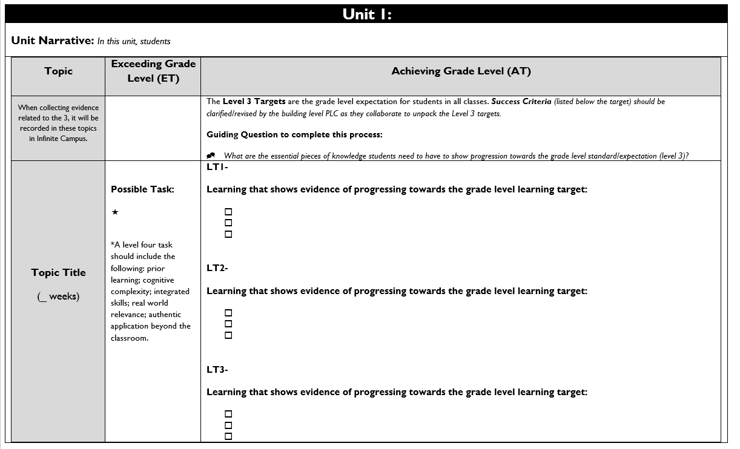

Topic Title:
Named topic in infinite campus, with approximate number of paced weeks
Exceeding Grade Level (ET):
Possible level four task listed including prior learning, cognitive complexity, integrated skills, real world relevance: authentic application beyond the classroom.

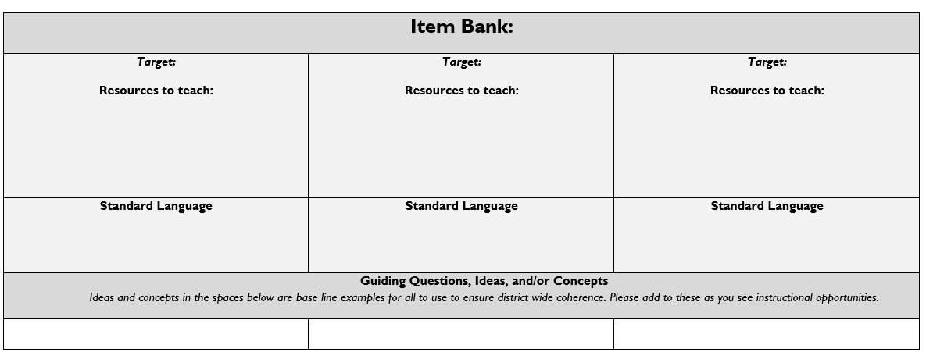
Achieving Grade Level
(AT):
Level 3 targets are listed within the topic scale and are the grade level expectation for students in all classes.
Success Criteria (listed below the target) should be clarified/revised by the building level PLC as they collaborate to unpack the Level 3 targets.

Item Bank:
Linked resources for each learning target. Guiding/Inquiry questions, ideas, and/or concepts are below the base line examples to ensure district wide coherence.

Evidence shows the student ... | Topic Score
Demonstrates proficiency (AT) in all learning targets and success at Level 4 | 4.0
Demonstrates proficiency (AT) in all learning targets with partial success at Level 4 | 3.5
Demonstrates proficiency (AT) in all learning targets | 3.0
Demonstrates proficiency (AT) in at least half of the learning targets | 2.5
Demonstrates some success criteria (PT) toward all learning targets | 2.0
Demonstrates some success criteria (PT) towards some of the learning targets | 1.5
Does not yet meet minimum criteria for the targets. | 1.0
Produces no evidence appropriate to the learning targets at any level | 0
Standards-Referenced Grading Basics
Our purpose in collecting a body of evidence is to:
- Allow teachers to determine a defensible and credible topic score based on a representation of student learning over time.
Start at Level 3 when determining a topic → score.
- Clearly communicate where a student’s learning is based on a topic scale to inform instructional decisions and push student growth.
- Show student learning of targets through multiple and varying points of data
- Provide opportunities for feedback between student and teacher.

Scoring
A collaborative scoring process is encouraged to align expectations of the scale to artifacts collected. Routine use of a collaborative planning and scoring protocol results in calibration and a collective understanding of evidence of mastery. Enough evidence should be collected to accurately represent a progression of student learning as measured by the topic scale. Teachers look at all available evidence to determine a topic score. All topic scores should be defensible and credible through a body of evidence.
Guiding Practices of Standards-Referenced Grading
- A consistent 4-point grading scale will be used.
- Student achievement and behavior will be reported separately.
- Scores will be based on a body of evidence.
- Achievement will be organized by learning topic and converted to a grade at semester’s end.
- Students will have multiple opportunities to demonstrate proficiency.
- Accommodations and modifications will be provided for exceptional learners.

***Only scores of 4, 3.5, 3, 2.5, 2, 1.5, 1, and 0 can be entered as Topic Scores.

Multiple Opportunities
Philosophically, there are two forms of multiple opportunities, both of which require backwards design and intentional planning. One form is opportunities planned by the teacher throughout the unit of study and/or throughout the semester. The other form is reassessment of learning which happens after completing assessment of learning at the end of a unit or chunk of learning.
Students will be allowed multiple opportunities to demonstrate proficiency. Teachers need reliable pieces of evidence to be confident students have a good grasp of the learning topics before deciding a final topic score. To make standards-referenced grading work, the idea of “multiple opportunities” is emphasized. If after these opportunities students still have not mastered Level 3, they may then be afforded the chance to reassess.

Topic 1: Computers & Problem Solving
Driving Question: How do computers help people solve problems?
Computers & Problem Solving | Achieving Grade Level (AT)
LT1A- Design a project that combines hardware and software components to collect and exchange data. (2-CS-02)
Learning that shows evidence of progressing towards grade-level learning target:
- Model how computer hardware and software work together as a system to accomplish a task.
- Analyze different apps and describe their processor.
- Select hardware and software components by considering factors such as functionality and accessibility.
LT1B- Recommend improvements to a design, based on an analysis of how users interact with the device. (2-CS-01)
Learning that shows evidence of progressing towards grade-level learning target:
- Describe how internal and external parts of computing devices function to form a system.
- Make recommendations for existing devices based on functionality and accessibility.

LT1C- Incorporate feedback from team members and users to refine a solution that meets user needs (2-AP-15)
Learning that shows evidence of progressing towards grade-level learning target:
- Collaboratively design a computational artifact that could help solve a problem.
- Explain and label your input, output, storage and process your app uses.
- Present your app for feedback for peers.

Topic 2: User Centered Data
Driving Question: How can we ensure that a user’s needs are met by our design?
User Centered Data | Achieving Grade Level (AT)
LT2A- Compare tradeoffs associated with computing technologies that affect people’s everyday activities and career options. (2-IC-20)
Learning that shows evidence of progressing towards grade-level learning target:
- Decide on users that may interact with apps.
- Decide needs of your users.
- Describe how the app meets the needs of users.

LT2B- Collaborate with many contributors through strategies such as interviews when creating a computational artifact. (2-IC-22)
Learning that shows evidence of progressing towards grade-level learning target:
- Analyze data from users on their interests and challenges.
- Define barriers that prevent users from getting their needs met.
- Define opportunities for users to explore their interests.
- Collaboratively create an app based off the data.
LT2C- Systematically test and refine programs using a range of test cases. (2-AP-17)
Learning that shows evidence of progressing towards grade-level learning target:
- Provide feedback as a user to help refine a program.

Topic 3: App Prototype

Driving Questions: What roles beyond programming are necessary to design and develop software? How do designers incorporate feedback into multiple iterations of a product?
App Prototype | Achieving Grade Level (AT)
LT3A- Incorporate existing code, media, or libraries into original programs and give attribution. (2-AP-16)
Learning that shows evidence of progressing towards grade-level learning target:
- Individually design a portion of an app.
- Embed each individual work into one digital space.
- Credit the contributors for each part.

LT3B- Distribute tasks and maintain a project timeline when collaboratively developing computer artifacts. (2-AP-18)\
Learning that shows evidence of progressing towards grade-level learning target:
- Collaboratively create an app with the users need being met.
- Collaboratively decide who is responsible for each task and when it needs to be completed.
- Individually document the work being done, including inputs, outputs, store, and process.
LT3C- Document programs in order to make them easier to follow, test, and debug. (2-AP-19)
Learning that shows evidence of progressing towards grade-level learning target:
- Design a paper prototype of an app.
- Document each screen, person responsible and the inputs and outputs.

